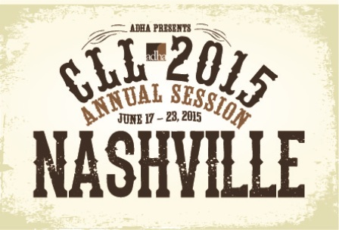
ADHA Exhibitor Group Block Housing Form
(Complete if requesting 5 or more rooms)
(For 4 rooms or less, book directly online staring early January )

Company Name:

Contact First/Last Name:

City: State: Zip:

Phone: Email:

Room Block: Indicate the number of rooms required on each day. ADHA will make the hotel reservations under the exhibitor contact’s name at one of the hotels in the ADHA block. The exhibitor contact is then responsible for making name changes/cancelling any unneeded reservations/establishing a master account with the hotel Group Coordinator directly.

Tuesday, June 16 No. of Rooms:_____
Wednesday, June 17 No. of Rooms:_____
Thursday, June 18 No. of Rooms:_____
Friday, June 19 No. of Rooms:_____
Saturday, June 20 No. of Rooms:_____
Sunday, June 21 No. of Rooms:_____
Monday, June 22 No. of Rooms:_____

Total Number of Room Nights:________

Select your preferred hotel:

ADHA Headquarters Hotel (limited availability)
Omni Nashville Hotel
Rate: $189+tax Single

ADHA Overflow Hotel
Hampton Inn Downtown Nashville Hotel
Rate: $259+tax

ADHA Overflow Hotel
Hyatt Place Nashville Hotel
Rate: $199+tax

Deposit: Each reservation requires a one night room and tax deposit.
Please provide credit card information below:

Credit Card Number:__________________________________________ Exp.________
Name on Card:___________________________________________________________
Signature:_______________________________________________________________

Cancellation Policy: All hotel reservations must be cancelled with the hotel that the block is arranged by Wednesday, May 6 to be eligible to receive the one night’s deposit returned.

Deadline for Submission: Please complete and return this from on or before February 27, 2015 to Dawn Amaskane at dawna@adha.net. Upon receipt ADHA will provide you with your group block confirmation along with hotel’s group coordinator name for you to manage your group block directly with the hotel.

