Figure 3. Forest plot of proportion of patients receiving RBC transfusion in studies reporting this outcome

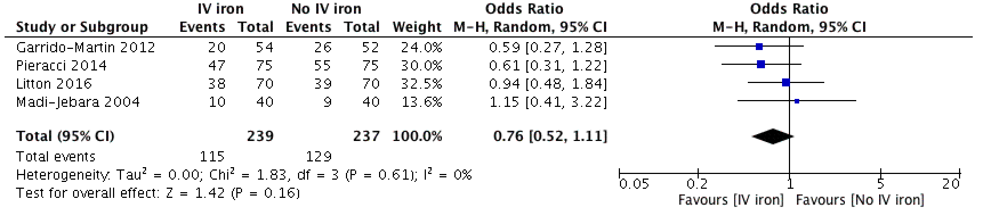

Figure 4. Forest plot of incidence of infection in studies reporting this outcome

