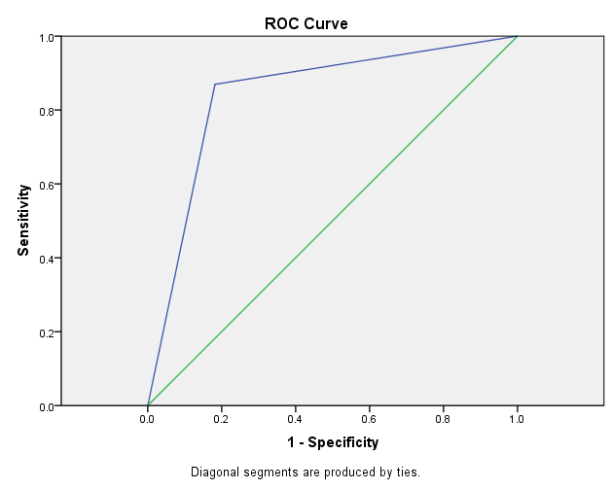
ROC for lung ultrasound to predict pneumonia is 0.844

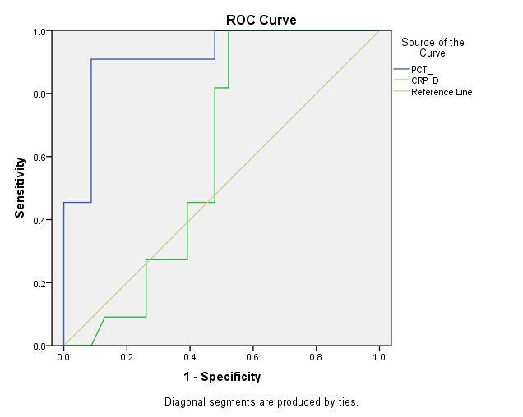
ROC for Procalcitonin and CRP to predict pneumonia were 0.91 and 0.60 respectively

