Table 1 – Baseline clinical characteristics of 55 consecutive patients with severe ARDS supported with and liberated from VV-ECLS, whom developed or not respiratory and hemodynamic complications
 |  | All patients  (n. 55) | Patients with complications  (n. 14) | Patients without complications  (n. 41)
Age, years |  | 45 (33 – 52) | 47 (39 – 52) | 41 (33 – 52) | 0.25
Gender, male |  | 41 (74%) | 11 (78%) | 30 (73%) | 0.96
BMI |  | 27.2 (23.2 – 33) | 28.4 (23.9 – 34.3) | 26.5 (23 – 33) | 0.34
Charlson comorbidity index |  | 0 (0 – 1) | 0 (0 – 1) | 0 (0 – 0) | 0.02
APACHE II |  | 29 (28 – 33) | 30 (27 – 33) | 29 (28 – 33) | 0.91
SOFA score |  | 12 (10 – 13) | 10 (8 – 12) | 12.5 (11 – 14) | 0.05
Cause of ARDS  Pulmonary  Extra-pulmonary* |  | 50 (92%)  7 (12%) | 13 (93%)  3 (22%) | 37 (90%)  4 (10%) | 0.85
MV prior to ECLS, days |  | 3 (2 – 7) | 2 (1.5 – 8) | 4 (2 – 7) | 0.60
Sweep gas off trial (SGOT), hours |  | 22 (15 – 25) | 24 (23 – 27) | 20 (12 – 25) | 0.03
ECLS blood flow during SGOT, L |  | 3.6 (3.2 – 4.2) | 3.6 (3.2 – 4.0) | 3.7 (3.2 – 4.3) | 0.9
Mechanical ventilation setting last hour of SGOT** | Mode of MV | PSV 34 (62%)  PCV 14 (25%)  CPAP 4 (7%)  APRV 1(2%)  NP 1 (2%) | PSV 6 (43%)  PCV 5 (32%)  CPAP 2 (12%)  APRV 0  NP 1 (4%) | PSV 28 (68%)  PCV 9 (23%)  CPAP 3 (7%)  APRV 1 (2%)  NP 0 | 0.99
 | Tidal volume, ml/kg PBW | 7.1 (6.0 – 9.2) | 9.2 (6.1 – 9.8) | 7.1 (6.0 – 8.4) | 0.02
 | Respiratory rate, min | 24 (18 – 28) | 26 (18 – 30) | 24 (19 – 26) | 0.41
 | Minute ventilation, L/min | 11 (9 – 13) | 12.5 (9.5 – 14) | 10.5 (8 – 13) | 0.18
 | Corr Min Vent, L/min | 13.3 (11 – 16) | 14.3 (13 – 16.9) | 12.2 (9.2 – 15.4) | 0.08
 | Ventilatory ratio | 2.4 (2.2 – 2.9) | 2.4 (2.2 – 2.9) | 2.0 (1.4 – 2.7) | 0.07
 | Mechanical power, J/min | 19.7 (13 – 22) | 21 (14 – 23) | 16.7 (13 – 20) | 0.39
 | PEEP, cmH2O | 10 (10 – 10) | 10 (10 – 11) | 10 (10 – 10) | 0.65
 | Peak Pressure, cmH2O | 23 (20 – 27) | 25 (21.5 – 26) | 23 (19.5 – 27) | 0.87
 | Driving pressure, cmH2O | 11 (10 – 15) | 12 (11 – 14.5) | 11 (9.5 – 15) | 0.96
 | PaO2/FiO2 ratio, mmHg | 183 (154 – 238) | 185 (139 – 201) | 183 (162 – 242) | 0.09
 | SOFA score | 7 (6 – 8) | 7 (5 – 9) | 7 (6 – 8) | 0.53
 | MAP | 78 (70 – 90) | 75 (70 – 80) | 83 (70 – 91) | 0.33
 | HR | 100 (90 – 105) | 105 (100 – 120) | 95 (90 – 100) | 0.01
Weaned from MV |  | 30 (54%) | 6 (43%) | 24 (58%) | 0.31
Duration of ECLS, days |  | 12 (1 – 18) | 12 (10 – 22.8) | 12 (10 – 18) | 0.58
Duration of MV, days |  | 18 (14 – 28) | 19 (13 – 36) | 18 (14 – 27) | 0.25
ICU length of stay, days |  | 21 (15 – 31) | 28 (14 – 36) | 21 (16 – 30) | 0.30
Hospital length of stay |  | 27 (17 – 41) | 31 (16 – 45) | 25 (17 – 38) | 0.40
Mortality |  | 1 (6%) | 1 (6%) | 0 (0%) | 0.12
†chi-squared test for difference in proportions, two-sided t test for continuous variables
*Trauma, pancreatitis, intra-abdominal sepsis, subarachnoid hemorrhage
*paramters from last hour on SGOT prior to decannulation from VV-ECLS
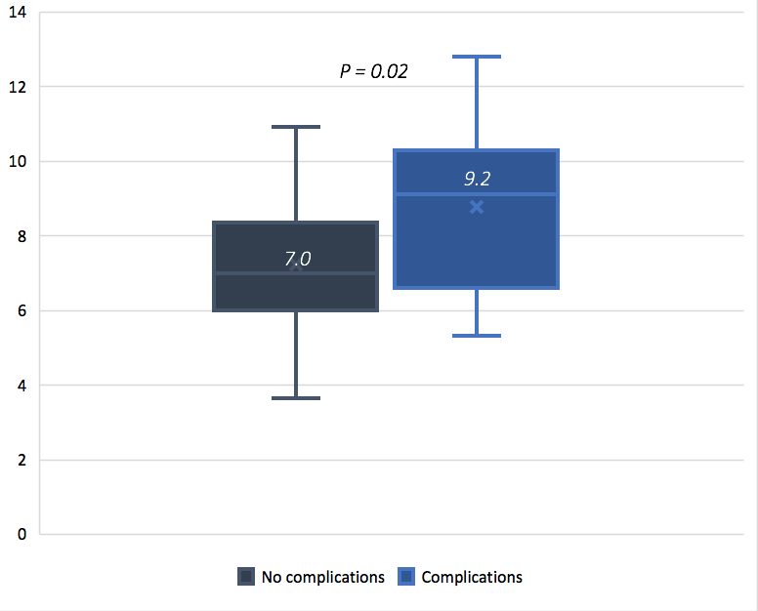

Figure 1 – Tidal volume per predicted body weight (Vt PBW ml/kg) during Sweep gas off trial – 1 hour prior to decannulation from VV-ECLS

Table 2 – for tidal volume per predicted body weight (adjusted for ventilator ratio and heart rate)
 | Odds ratio | 95% CI | P value
Tidal volume PBW | 1.50 | (1.04 – 2.17) | 0.031
Ventilatory ratio | 1.37 | (0.58 – 3.21) | 0.467
Heart rate | 1.05 | (1.00 – 1.11) | 0.023

