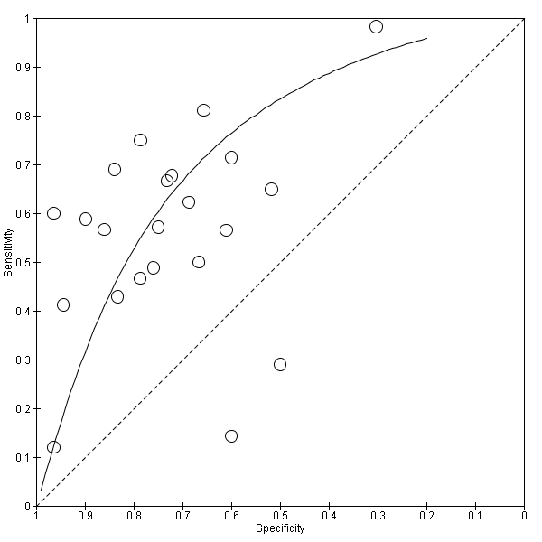
Figure: Summary receiver operating characteristic (SROC) plot of C-reactive protein for neonatal infection. Study estimates of sensitivity and specificity are shown with the SROC curve.

