Correlation analysis between molecular markers and SCORAD scale
N.Hajiyeva, A.Akhundova, N.Mammadova, P.Orujova
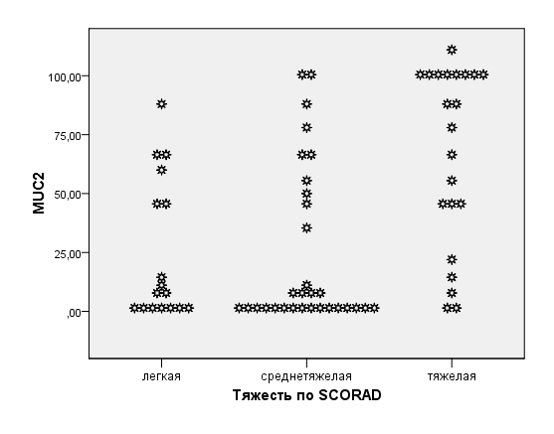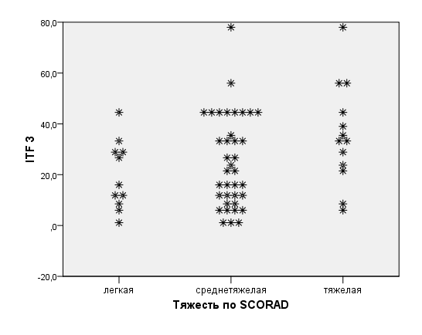
mild average heavy
SCORAD
mild average heavy
SCORAD

