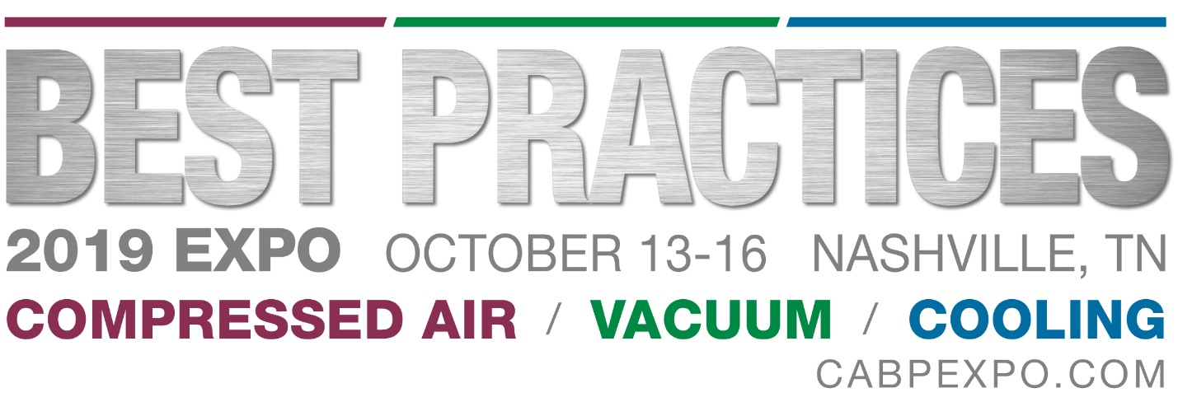

Exhibitor Email Invitation
This is suggested copy for Best Practices EXPO exhibitors to customize and send to their database in July and again in September to promote their participation.

SUBJECT LINES:
We’ll be at Best Practices EXPO in Nashville – will you?
Join us at Best Practices EXPO in Nashville, October 14-15
Don’t miss all the innovation! Meet us at booth <enter booth #> at Best Practices EXPO 2019

Dear <Name>,
<Exhibitor Name> will be exhibiting at Best Practices EXPO and we’d like to extend a personal invitation for you to join us in Nashville, October 14-15 and visit our booth <enter booth #>. We will be displaying our latest <insert highlight of the products, technologies, services you will be showcasing this year>.
Everything you need to optimize onsite utilities powering automation is waiting for you at Best Practices EXPO. To learn more and register, visit www.capbexpo.com
We hope to see you there.
Best regards,
<Your Signature>

Best Practices EXPO
October 14-15
Conference August 14-16
Nashville Music City Center| Nashville, TN
https://www.cabpexpo.com

