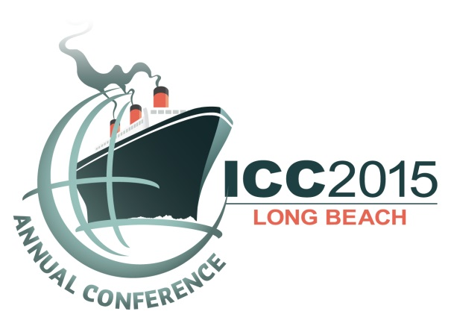

Sunday, September 27 | 3 – 7 pm
Monday, September 28 | 10 am – 5pm
ICC Resume Clinic

ICC will offer conference attendees the chance to receive individual advice on resumes and cover letters. Sponsored by Sequence Staffing, Frank De Safey and Craig Travis in addition to private and public sector hiring managers, organization fellows, and division officers, and other volunteers will spend 15-20 minutes with attendees reviewing resumes and offering customized job search advice.

A living document, the purpose of your resume is to not only encapsulate and communicate your skills and experience, but to catch an eye and get a phone call and interview from a prospective employer.

In today’s world of electronic media, large databases, impersonal connections, and strong competition for fewer jobs you, the job candidate, have to cleverly navigate through these obstacles to rise above the others if you hope to have any chance of being seen and heard.

Producing a resume that successfully moves you through these perilous channels and elevates you to an interview requires a special effort, keen skills and adaptability. It is the single most important personal marketing material you must have for your career.

Your resume must tell an employer or hiring manager a compelling story about you and your professional experience, knowledge and skill set. More than ever, your resume is critical to the success of your employment and career advancement. Failure to craft one that achieves this is not an option.

ICC in partnership with Sequence Staffing is conducting a resume clinic designed especially with consideration of the specific needs of ICC Members. This is a special opportunity to have a personal 20-minute, one-on-one resume critique by the recruiting professionals and candidate marketing experts at Sequence Staffing, the premier executive search and recruitment firm committed to providing recruiting and career planning solutions to the building, planning, environmental, engineering, and construction industries throughout the United States and around the world. It is also a unique opportunity to get feedback directly from ICC leaders and peers that have keen insight and hands on experience with hiring and requirements of industry professionals.

This is a private one-on-one session to have an industry professional review your resume and provide you with an expert’s eye on the strengths and effectiveness of your resume, and specific ways you can improve it to make it stand apart from the others.

Learn the secrets to developing a successful resume that is eye catching, provocative and tells a compelling story about you that employers are eagerly seeking. Hear firsthand what it takes to establish, build, and polish your brand so you can successfully market yourself in today’s highly competitive job market.

Individual appointments at specific time slots are available on a first-come, first-served basis at the conference in Long Beach. Remember to bring copies of your resume and cover letter for discussion.

