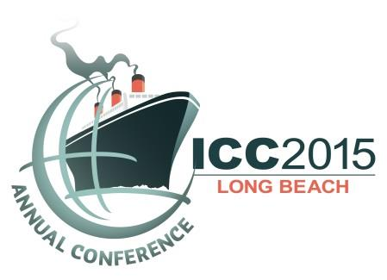

Monday, September 28 | 1:30 – 5:30 pm
ICC Career Planning Workshop

ICC in partnership with Sequence Staffing is offering a three hour in-depth Career Planning Workshop specifically customized to our ICC Members.

If you’re an experienced ICC Member considering a job change or progressing up within the industry, you’ll need more than an updated resume. You’ll need to think about, learn and understand the new methods of marketing yourself in an employment landscape that’s shifted radically over the past few years. You will also need to understand what it means to brand yourself and constantly reinvent your professional career.

The employment landscape has changed, and more than ever ICC professionals need to evolve with it. Social aspects, a changing workforce demographic and vastly new employment processes / technology are driving new ways in the way we seek and hold jobs.

Learn about new channels, evolving trends and what it means to create a brand for yourself. Get the tools to showcase the advantages you bring, align your job hunt with today’s marketplace and make a successful career move. Discover how to enhance the excellent advantages you as an experienced ICC Member bring to a new job and how to appropriately call attention to your skills. In this workshop you will also have the opportunity to align your job hunt with evolving trends, approaches and demands in the workplace.

The session will include practical hands-on exercises, tips and handout materials for building your career network, producing customized personal brand marketing materials, defining and building you brand, as well as interview preparation and advice for securing your next career opportunity.

This is a special opportunity to receive in-depth advice from the employment and branding experts at Sequence Staffing, the premier executive search and recruitment firm committed to providing recruiting and career planning solutions to the building, planning, environmental, engineering, and construction industries throughout the United States and around the world.

Key to this session is that workshop leaders will walk you through Sequence's time-tested personal assessment process, The Sequence VITAE Exercise, that will greatly aid you in your career planning efforts. Vitae in Latin literally means “life.” Our lives are a series of actions and events traced in order by time. It’s a sequence. It’s a particular order in which related acts and events follow each other. The Sequence VITAE Exercise is a simple five-step orderly process designed to help you define your value, target your goals, take inventory and establish, build, polish, and market your personal brand. The Sequence VITAE Exercise book will be available to all workshop participants.

Frank De Safey and Craig Travis of Sequence will offer their professional knowledge, experience and expertise with special consideration of today’s era of electronics, online applications and the ins and outs of navigating the ever-changing employment industry landscape. They will also focus specifically on personal branding and development.

Session availability is on a first-come, first-served basis at the conference in Long Beach. Remember to bring copies of your resume and cover letter for discussion or possible consideration.

