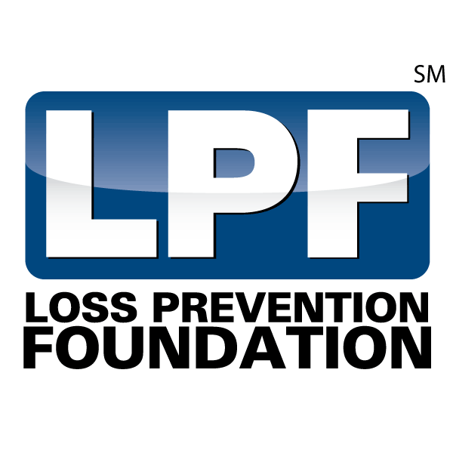
‘Swing for Certification ‘

Golf Tournament

PLATINUM SPONSORSHIP (exclusive) $12,500
- Exclusive naming rights
- The Swing for Certification Golf Tournament, Presented by Your company
- Logo on shirts provided for all participants
- Logo on 10 sponsorship signs on course/clubhouse
- Recognition on the LPF website, social media, media releases and all event emails.
- Includes 8 green fees.
- Includes 4 tee box sponsorships.
- Sponsorship recognition plaque.
GOLD SPONSORSHIP $7,500
- Logo on 5 sponsorship signs on course/clubhouse.
- Recognition on the LPF website, social media, media releases and all event emails.
- Includes 6 green fees
- Includes 3 tee box marker sponsorship.
- Sponsorship recognition plaque.
SILVER SPONSORSHIP $5,000
- Logo on 3 sponsorship signs on course/clubhouse.
- Recognition on the LPF website, social media, media releases and all event emails
- Includes 4 green fees.
- Includes 2 tee box sponsorship.
- Sponsorship recognition plaque.
BRONZE SPONSORSHIP $3,000
- Logo on 1 sponsorship signs on course/clubhouse.
- Recognition on the LPF website, social media, media releases and all event emails
- Includes 4 green fees.
- Includes 1 tee box sponsorship.
- Sponsorship recognition plaque.
Beverage Cart Sponsorship $4,000
- Includes 4 green fees & Beverage Cart Signage.
- Sponsorship recognition plaque.
Lunch Sponsorship $3,000
- Includes 4 green fees & Thank You signage during lunch event.
- Sponsorship recognition plaque.
For more information on sponsorship opportunities, please contact: Terry Sullivan Terry.Sullivan@LosspreventionFoundation.org 949-254-4881 or visit us online at www.LossPreventionFoundation.org

