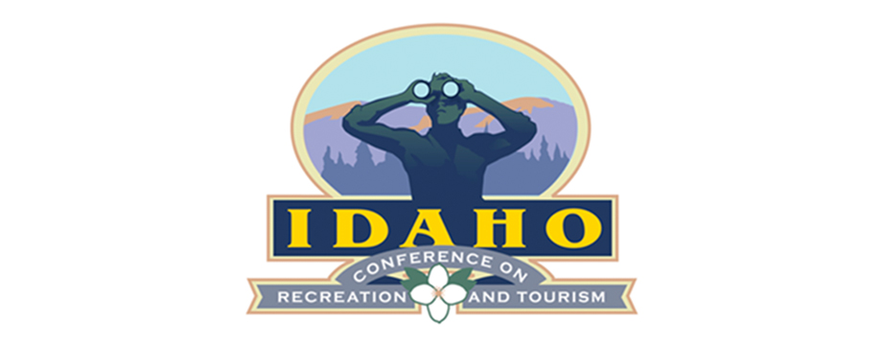

2019 Sponsorship Opportunities
Gem - $3,000*
[Level One Activity Sponsorship]
Video/short presentation during conference
Additional conference registration
Listing in conference agenda
Vocal recognition during “housekeeping” announcements
Visual representation at sponsored event
Logo in sponsor reel
OPPORTUNTIES:
6-Keynotes
2-Evening Receptions
Tuesday, October 21: – ILRA/STAR PARTY (Reserved by Sponsor)
Wednesday, October 22: Taste of Idaho
2-Luncheons
Garnet - $2,000*
[Level 2 Activity Sponsorship]
Listing in conference agenda
Vocal recognition during “housekeeping” announcements
Visual representation at sponsored event
Logo in sponsor reel
OPPORTUNITES:
3- Monday Afternoon Field Trips
2-Breakfast Sessions
4-Coffee Breaks
Syringa - $1,000
Listing in conference agenda (contact information)
Logo in sponsor reel
All Sponsorships Include:
1 conference registration
1 6ft table
2 chairs
Ample opportunities to network with conference attendees
Questions? Contact Kathy Schofield Kathy.Schofield@commerce.idaho.gov

