DEADLINE: 11TH AUGUST 2017

Please Return Form to:
KINGSMEN EXHIBITS PTE LTD
Kingsmen Creative Centre, 3 Changi South Lane, Singapore 486118
Tel : (65) 6880 0049 Fax : (65) 6831 1368
FORM E2A
Attn : Ms. Cassandra Loe Email : cassandraloe@kingsmen-int.com

HIMSS AsiaPac17 Conference & Exhibition
ELECTRICAL SERVICE
- Orders are valid only when accompanied by full remittance. Payment could be made by Singapore local cheque, bank draft, telegraphic transfer (See Payment Details)
- Please note that withholding & government taxes, if any, shall be borne by the client. Invoices will be subjected to a bank charge of S$35.00 or S$50.00 (Orders above S$5000.00) for payment via telegraphic transfer.
- Amount paid are non-refundable for cancellation received after 18th August 2017.

This form must be completed and returned by Exhibitors if service is required. (Please type / write in block letters.)
- Only the official contractor is permitted to undertake electrical works from the source of supply in the exhibition hall.
- Kindly order your additional requirements only.

NO. | ITEM | ADVANCED RATE (SGD)  Submit on/before  11th August 2017 | STANDARD RATE (SGD)  Submit after  11th August 2017 | QTY | TOTAL  (SGD)
SECTION A – INDIVIDUAL FITTINGS
1 | 100W Standard Spotlight | 65.00 | 84.50
2 | 100W Long Arm Spotlight | 75.00 | 97.50
3 | 40W Fluorescent Light, 1.2mL (BATTEN FITTING) | 65.00 | 84.50
4 | 40W Fluorescent Light, 1.2mL (For Lightbox) | 70.00 | 91.00
5 | 50W Standard Halogen Spotlight | 65.00 | 84.50
6 | 50W Long Arm Halogen Spotlight | 75.00 | 97.50
8 | 150W Floodlight | 155.00 | 201.50
9 | 13Amp/230V SP 50Hz AC Socket (Max 800W) (Not for lighting use) | 65.00 | 84.50
10 | 13Amp/230V SP 50Hz AC Socket with 24hrs Supply (Max 800W) (Not for lighting use) | 130.00 | 169.00
11 | 15Amp/230V SP 50Hz AC Socket (Max 3kW) (Not for lighting use) | 95.00 | 123.50
SECTION B – FOR CONNECTION TO LIGHTING ONLY
12 | Per Light Fitting Connection (Up to 100W) | 55.00 | 71.50
13 | Per Light Fitting Connection (Up to 300W) | 110.00 | 143.00
14 | Per Light Fitting Connection (Up to 500W) | 165.00 | 214.50
15 | LED Lighting Connection Per Meter Run | 50.00 | 65.00
* Subject to 7% Goods & Services Tax (GST)  * GST is not applicable for foreign-based exhibitors. |  | Total Cost Before GST
 |  | 7% GST*
 |  | Total Cost Including GST
Please indicate the locations of the above requirement on the Service Location Plan. (Form E2B)
PAYMENT (Please select preferred method of Payment)
- For Local Exhibitors: Crossed cheque or bank draft made payable to Kingsmen Exhibits Pte Ltd.
Mailing Address: Kingsmen Creative Centre, 3 Changi South Lane, (S) 486118
- For Overseas Exhibitors: Telegraphic Transfer – Please make payment in SGD to the following account: Kingsmen Exhibits Pte Ltd
Bank Name: United Overseas Bank (Novena Branch), 238A Thomson Road, #01-38, Novena Square, (S) 307685
Account No.: 106-303-314-1, Swift Code: UOVBSGSG

Company Name : _____________________________________________________________________________________________ Stand No: ___________
Address : __________________________________________________________________________________________________________________
Tel : ___________________________ Fax: __________________________ E-mail: _____________________________________________
Authorized by : ___________________________ Signature: ______________________________________ Date: ___________________________________
DEADLINE: 11TH AUGUST 2017

Please Return Form to:
KINGSMEN EXHIBITS PTE LTD
Kingsmen Creative Centre, 3 Changi South Lane, Singapore 486118
Tel : (65) 6880 0049 Fax : (65) 6831 1368
FORM E2B
Attn : Ms. Cassandra Loe Email : cassandraloe@kingsmen-int.com

HIMSS AsiaPac17 Conference & Exhibition
SERVICE LOCATION PLAN - COMPULSORY
- Orders are valid only when accompanied by full remittance. Payment could be made by Singapore local cheque, bank draft, telegraphic transfer (See Payment Details)
- Please note that withholding & government taxes, if any, shall be borne by the client. Invoices will be subjected to a bank charge of S$35.00 or S$50.00 (Orders above S$5000.00) for payment via telegraphic transfer.
- Amount paid are non-refundable for cancellation received after 18th August 2017.

This form must be completed and returned by all Exhibitors. (Please type / write in block letters.)

- Indicate clearly the location of your utilities such as power outlets, spotlights, water and compressed air on this Form.
- It is imperative that you complete this Form as it will be used to install your requirements at the correct locations before you arrive on-site.
- Please ensure that the positions of the lights are on the wall or fascia (unless your booth has an interior structure to which the lights can be attached).
- If the location plan of any service is not submitted with the order form before the stated deadline, it will be placed at the discretion of the Official Contractor.

Important Note
- Light boxes are charged accordingly to the number of tubes in each light box, using the light connection or 40W fluorescent tube rate, whichever applicable.
- If lighting fittings are brought in by the exhibitors for lighting purposes, the lighting connection charges will apply on per bulb/per tube basis.
- All electrical connection to equipment must be tested and approved by the Organizer’s appointed licensed engineer prior to the turning on of the power supply. The Organizer reserves the right to terminate the power supply to any installation which are found dangerous or may cause any disruption to the power supply.

 | Legend (Use only the items applicable):  *Please indicate neighboring booth number
  *Indicate Adjacent Booth No. in this direction. _______ | Left |  |  | Back of Booth |  |  | Right |  |  | *Indicate Adjacent Booth No. in this direction. _______
  *Indicate Adjacent Booth No. in this direction. _______ | Left |  |  | Front of Booth (Aisle) |  |  | Right |  |  | *Indicate Adjacent Booth No. in this direction. _______
   | SPOTLIGHT |  |  | FLUORESCENT LIGHT
  SO | SOCKET POINT |  | F | FLOODLIGHT

Company Name : _____________________________________________________________________________________________ Stand No: ___________
Address : __________________________________________________________________________________________________________________
Tel : ___________________________ Fax: __________________________ E-mail: _____________________________________________
Authorized by : ___________________________ Signature: ______________________________________ Date: ___________________________________

ELECTRICAL CATALOGUE
LIGHTING
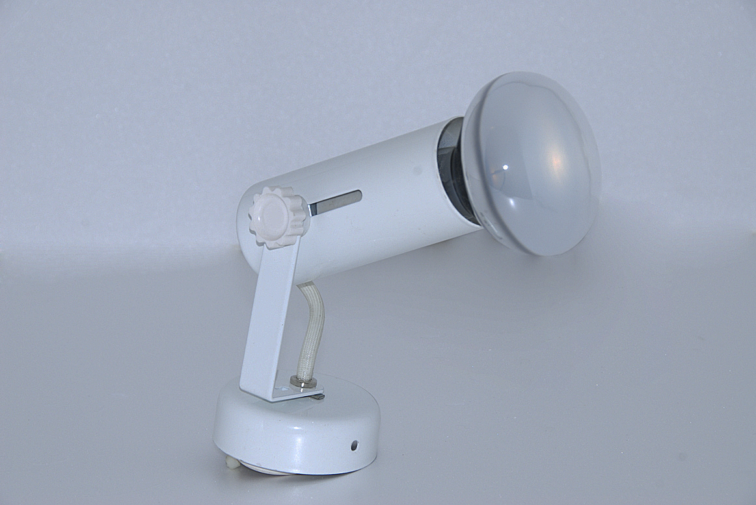 | 100W Standard Spotlight | 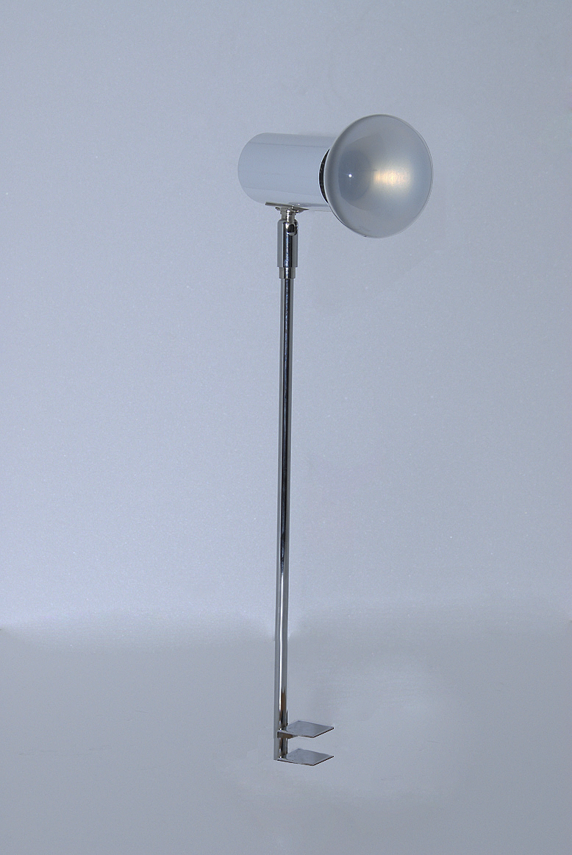 | 100W Long Arm Spotlight
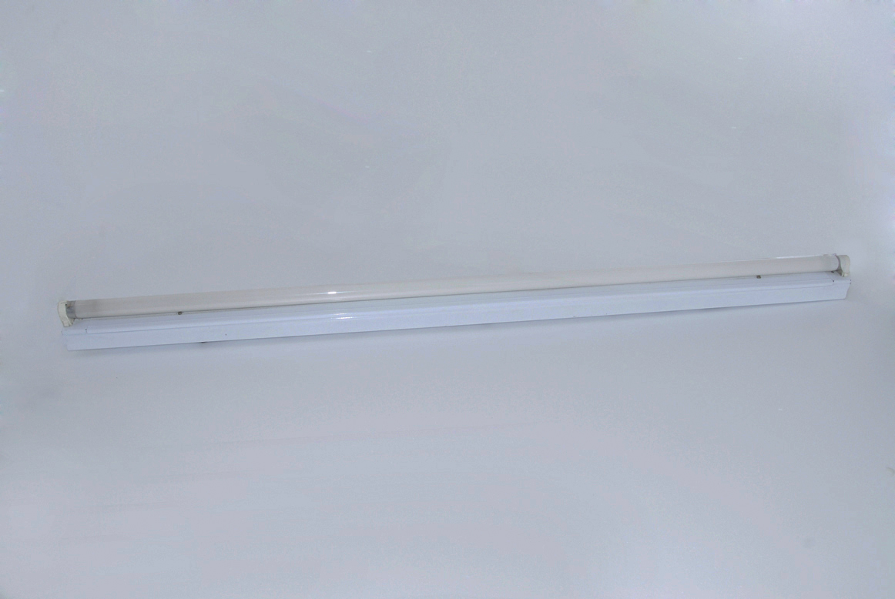 | 40W 1.2mL Fluorescent Light  (Batten Fitting) | 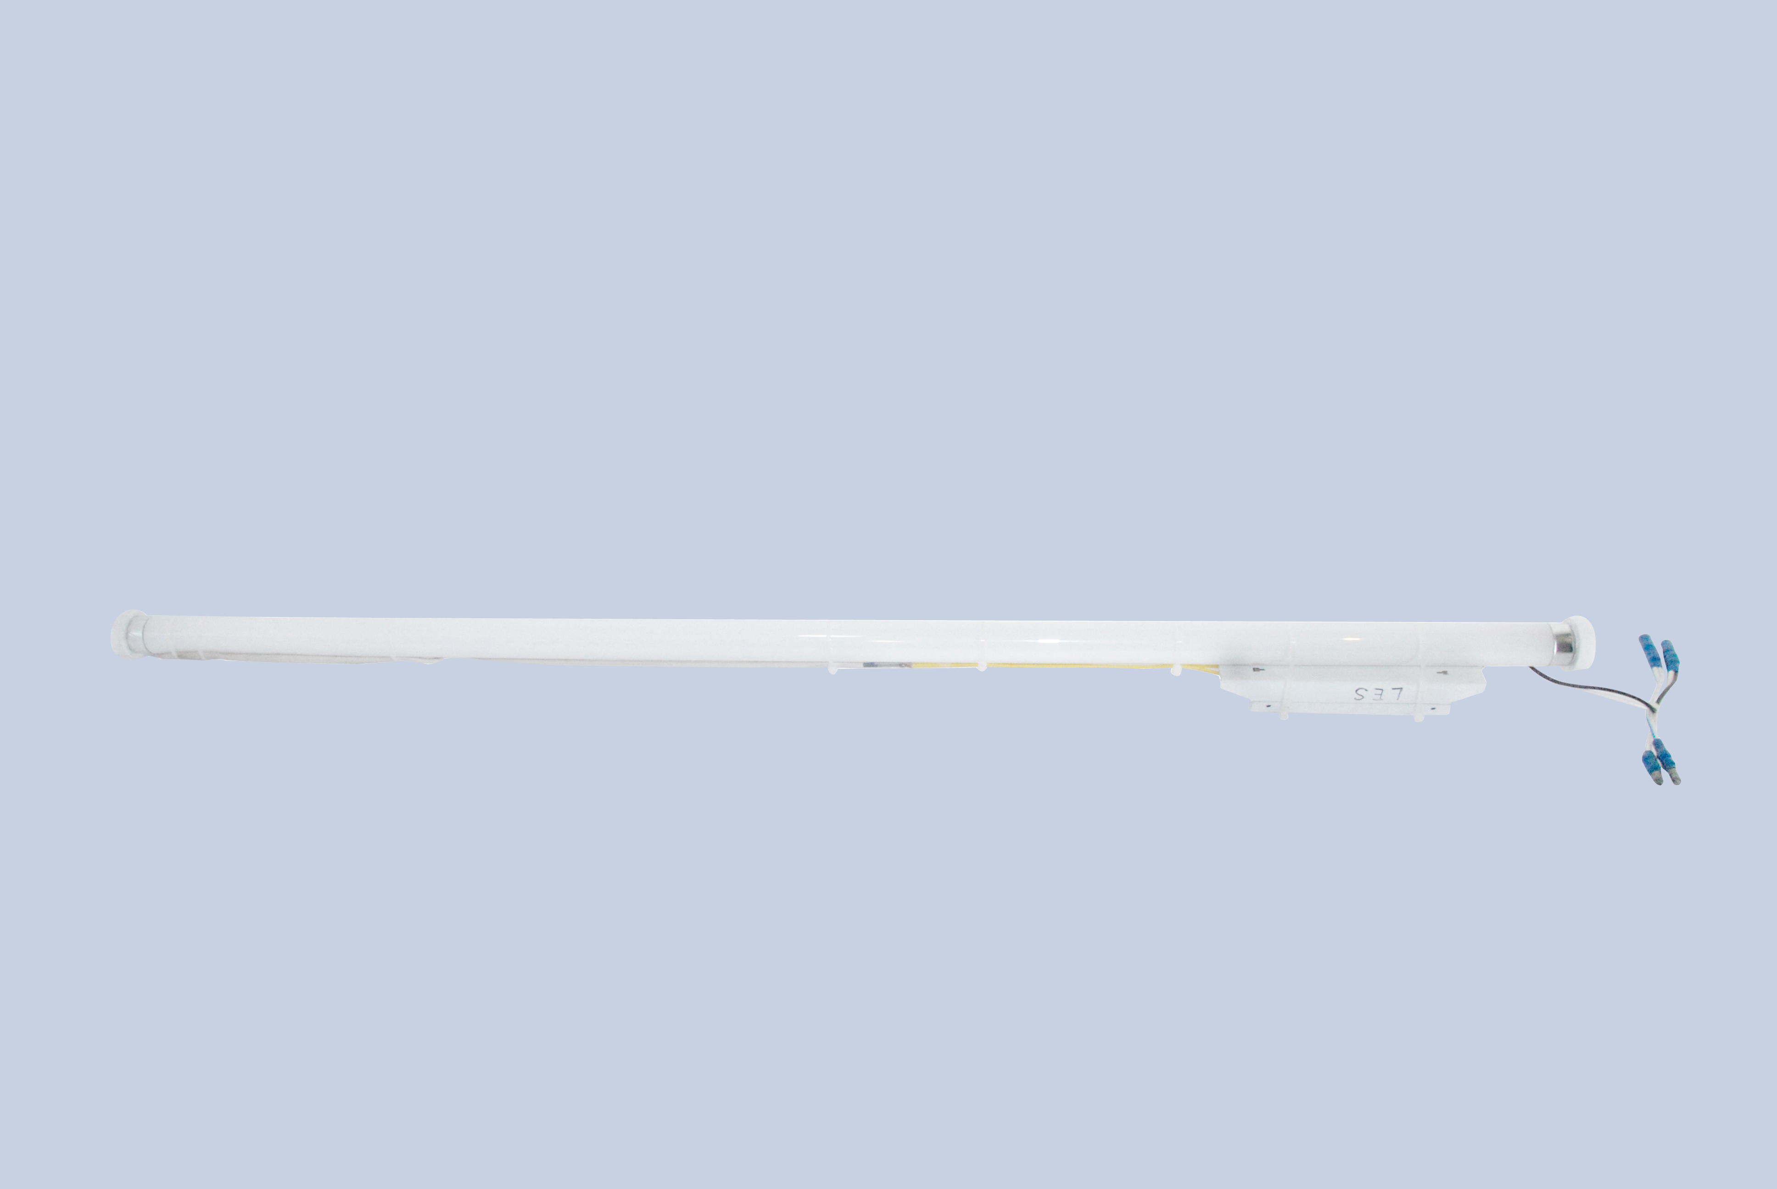 | 40W 1.2mL Fluorescent Light  (Loose Fitting)
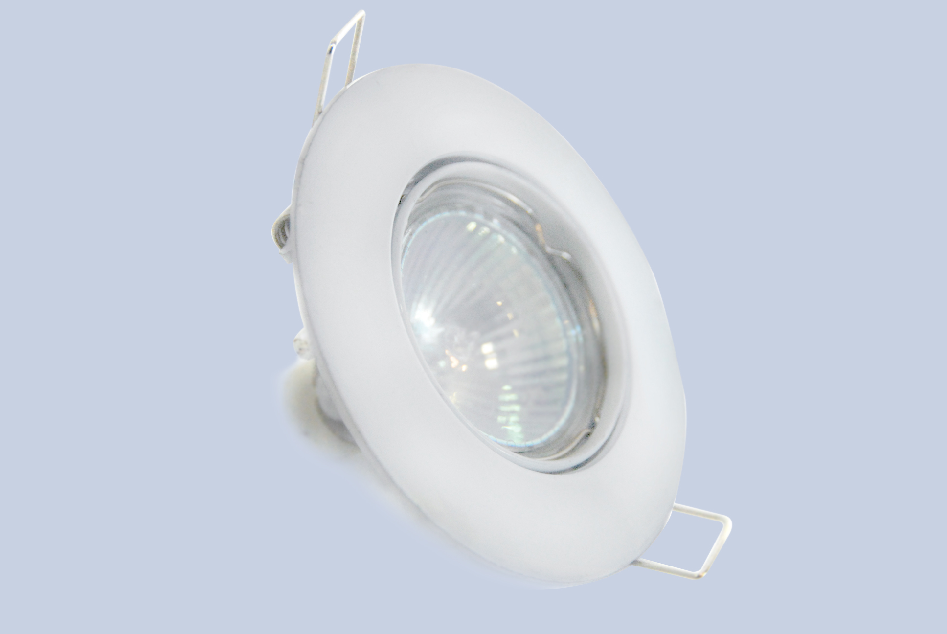 | 50W Downlight | 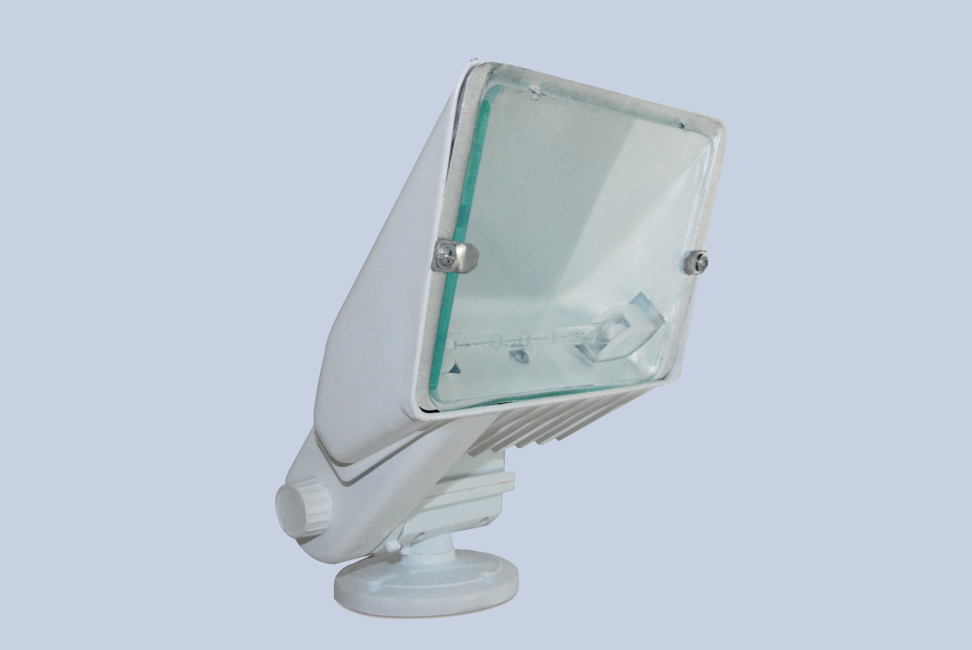 | 150W/300W Floodlight
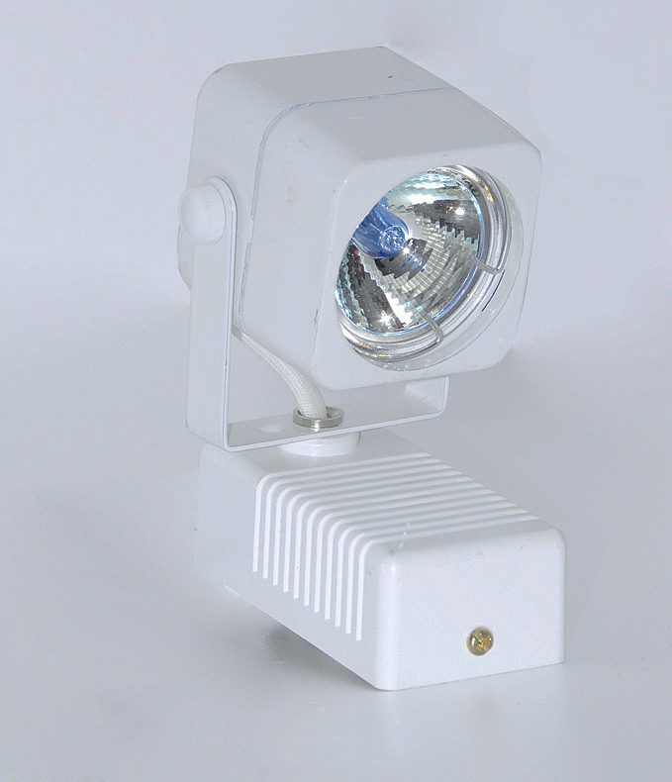 | 50W Standard Halogen Spotlight | 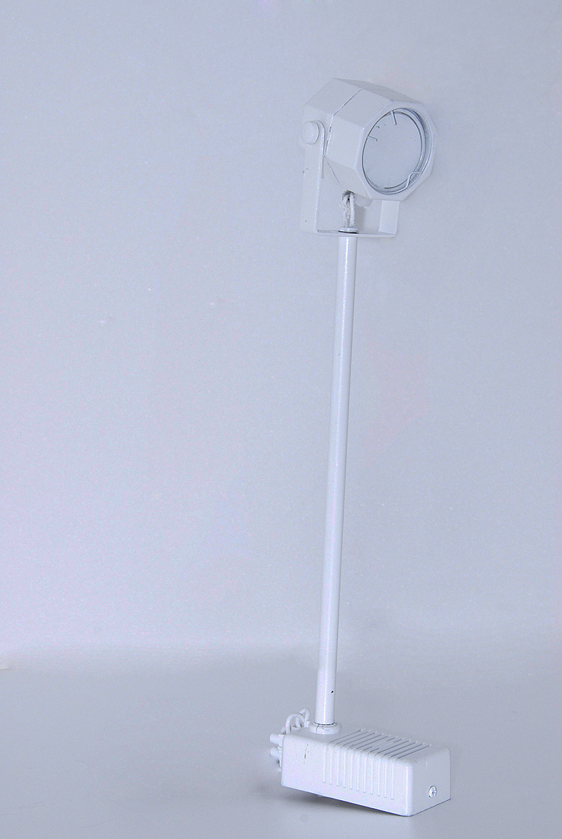 | 50W Long Arm Halogen Spotlight
POWER SUPPLY
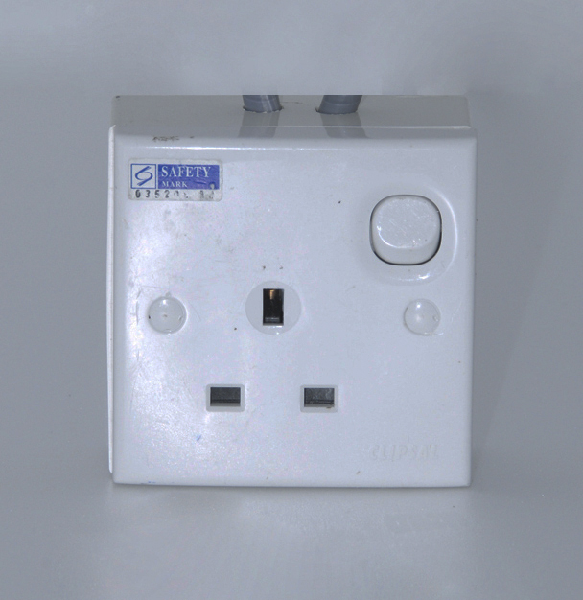 | 13A/230V SP 50/60 Hz Powerpoint (Not for lighting use) | 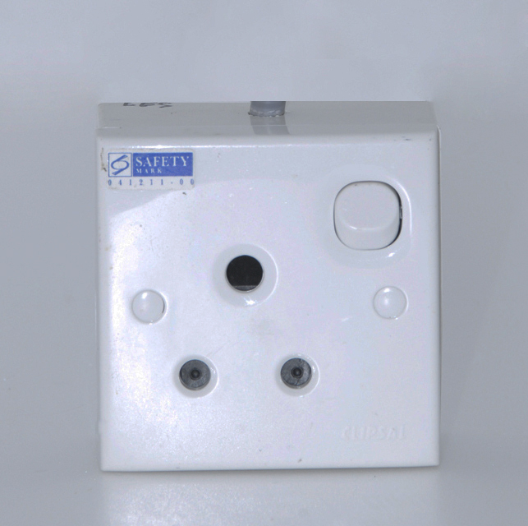 | 15A/230V SP 50/60 Hz Powerpoint (Not for lighting use)

