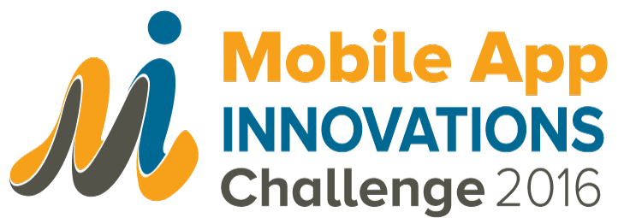

Introduction
Ministry of Health and HIMSS Middle East are searching for outstanding mobile applications that delight customers and engage patients.

Today we call upon Saudi Healthcare Organizations, Innovators and solution providers to offer brief, rapid fire demonstrations that show high patient and customer engagement. Superior mobile applications and patient portals will go behind scheduling and will provide clinically relevant health information to patients and potentially engage them in wellness and healthy lifestyles.

Fee Structure
No fee is required for participation.

Timeline
Cutoff Date for Submission: 29 August 2016

Why Should I Participate?
- 1 Winner will be awarded with a Trophy and Certificate
- 2 Runner-Ups will be awarded with a Certificate
- Exposure and recognition on-site to the Ministry, healthcare providers, vendors, venture capitalists, potential partner organizations and more!
- Industry-wide recognition and media attention through HIMSS Middle East
On-site Award Judging Process
- Each finalist will be given 10 minutes to present their app to a live audience. Presentation date and time will be confirmed at a later date
- Presentation order is random
- After all the presentations, attendees will vote and the results will be tabulated
- 1 winner and 2 runner-ups will be announced at the close of the day
Audience Voting Guidelines
- Technology Innovation: What challenge does your app seek to resolve and how is your app innovative compared to other apps and solutions in the market
- Short-term to long term impacts in multi-dimensions: On patients, consumers, professionals, the user, the economy (if applicable)
- Benefits from using the app: Financial and Non-financial

SUBMISSION FORM

Organization Name:
Organization URL:
Organization Point of Contact | Name:
 | Email:
 | Office: Number:
 | Mobile Number:
Innovation Name:
Tell us (in 200 words or less) about your app:
Name 3 factors that differentiate this app from similar apps / solutions:
Please elaborate on how the app is improving healthcare outcomes; case studies will be added bonus.
Please submit the completed form to Ms. Priscilla Heung at pheung@himss.org

