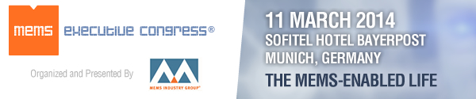

11 March, 2014
Sofitel Hotel Bayerpost, Munich, Germany

An executive forum promoting the commercialization of MEMS

European Innovators Give Keynotes at MEMS Executive Congress Europe 2014
MEMS Industry Group (MIG) will host its third annual MEMS Executive Congress® Europe, 11 March, 2014 in Munich, Germany, featuring keynote speakers from two European companies that are building the foundation for a “MEMS-enabled life.”

Morning Keynote Speaker Rudi De Winter, CEO of X-FAB Group, will present “Risks and Opportunities in Developing MEMS Business.”
MEMS is changing the way that we live our lives. From smartphones, tablets and pico-projectors to vehicle stability systems and medical diagnostic devices, MEMS technology is enhancing our experience with electronic devices in countless ways. Small companies, start-ups and universities are able to help drive this innovation by outsourcing the volume manufacturing of their devices to foundries.

But in the world of MEMS manufacturing, one size does not fit all. Unlike the traditional CMOS foundry model, which relies on standardization for high-volume manufacturing output, MEMS manufacturing must support diversification, smaller volumes and the need for dedicated equipment.

In his keynote speech, Mr. De Winter will address the commercial, technical, manufacturability, market and investment risks in developing MEMS business, explaining how to overcome them to reap rewards. Mr. De Winter will also provide examples of MEMS and 3D heterogeneous integration by sharing the investment story in two startups: MicroGen Systems (energy harvesting) and X-Celeprint (mass micro-transfer printing technology).

Afternoon Keynote Speaker Klaus Meder, president of Automotive Electronics at Robert Bosch, will explore “MEMS in Our Connected World.”
We live in a connected world. From automobiles and smartphones to gaming devices and ‘smart home’ systems, the products on which we depend are connected wirelessly to the Internet, to wireless sensor networks, and to one another. All these products rely on MEMS sensors.
Bosch—as a pioneer of MEMS sensors—has driven their proliferation from the automotive world into the consumer electronics field. Today, cars have up to 50 MEMS sensors, and smartphones up to a dozen different sensors. Now, at the dawn of the Internet of Things and smart wearable devices, MEMS sensors are also becoming critically important to all kinds of connected devices.
Consumer-electronics MEMS sensors from Bosch Sensortec are already enabling the connected world in a variety of ways. Leveraging its component technology to further pursue this connected world, Bosch founded Bosch Connected Devices and Solutions (BCDS) in 2013. BCDS will provide networked sensors and actuators for the next chapter of the MEMS success story: the Internet of Things and Services and wearable devices.
During his keynote presentation, Mr. Meder will describe some of the new applications made possible by wirelessly connected, multifunctional, smart sensors with extremely low energy consumption.
Please join us 11 March, 2014 at MEMS Executive Congress Europe 2014
08:45—9:30 Morning Keynote by Mr. Rudi De Winter, CEO, X-FAB Group, with an introduction by Platinum Sponsor EV Group
16:00-16:45 Afternoon Keynote by Mr. Klaus Meder, president of Automotive Electronics, Robert Bosch GmbH and introduction by Gold Sponsor SPTS
Should you wish to join us as a member of the press, we encourage you to review our press credentials. Please direct all inquiries for press registration to Ingrid Daschner, European public relations on behalf of MIG, tel: +49 (0)89 89 40 85-11, email: ingridd[at]johnsonking.de.

Host Organization
MEMS Industry Group
Connect with MEMS Industry Group!

Sponsors
Premier sponsors of MEMS Executive Congress Europe 2014 include: Platinum Sponsor – EV Group; Gold Sponsor - SPTS Technologies; Silver Sponsors – Analog Devices and Freescale Semiconductor; and Bronze Sponsor - Applied Materials.
Supporting sponsors and partners include: acam, Akustica, Bosch Automotive Electronics, Bosch Sensortec, Fries Research & Technology (FRT), imec, IVAM, MicroTEC Südwest, Plan Optik, SEMI, Smart Systems Integration, Solid State Technology, Tronics, X-FAB MEMS Foundry, Yole Développement and the ZVEI.

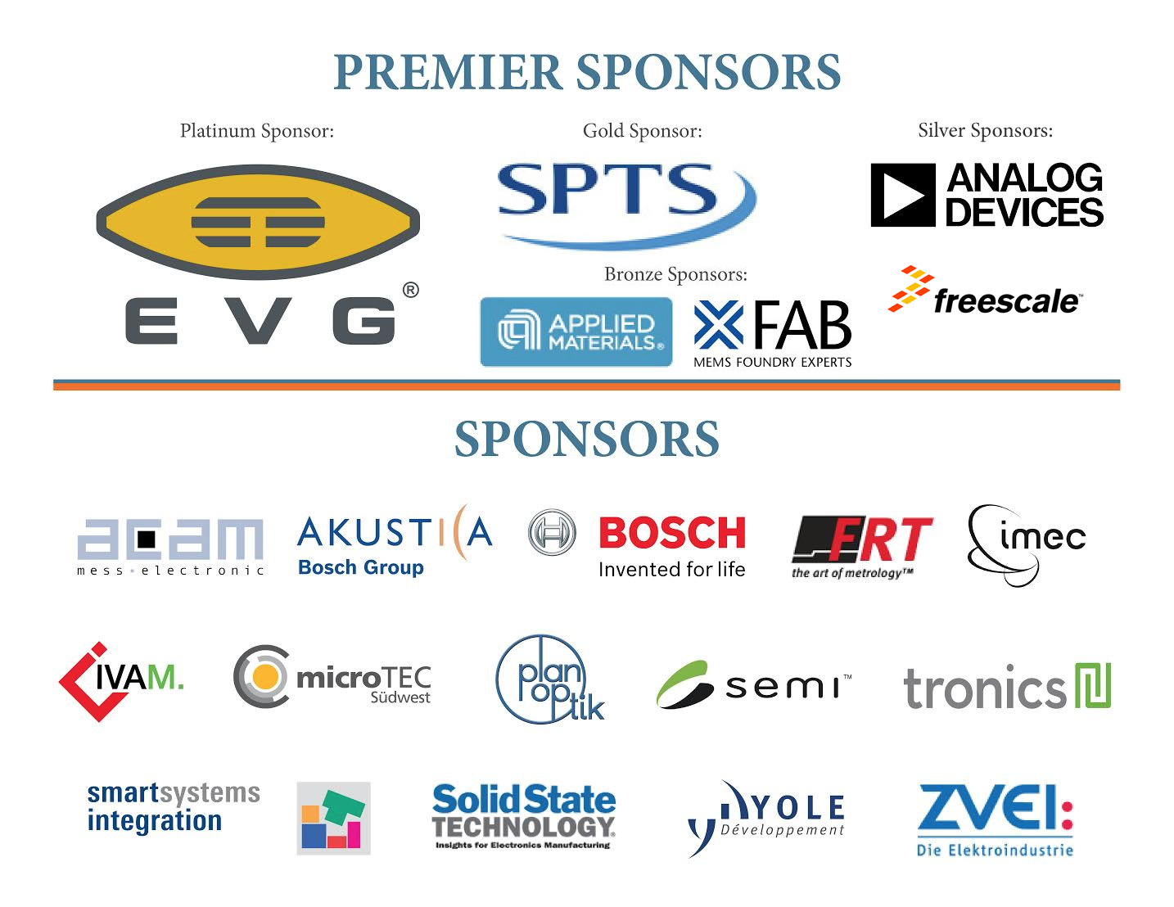
MEMS Industry Group®, MEMS Executive Congress® and the MEMS Industry Group® logo are registered trademarks of MEMS Industry Group®. All product and company names are trademarks or registered trademarks of their respective holders.
MEMS Industry Group®- 1620 Murray Avenue, Pittsburgh, PA 15217. Phone: 1.412.390.1644

