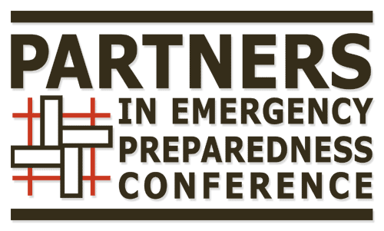 |  |  |  |  |  |  |  | Membership Application
Name
Organization
email
Mobile Phone: |  |  |  |  |  |  |  |  |  |  | Business phone:
Street Addresss
City, State, Zip
Which business sector would you say you currently most represent:
Public: |  |  |  |  |  | Private: |  |  | Other (e.g. Health care, University, Non profit, etc.):
Please rank which committees interest you (1 most interested 5 least interested)
 |  | Education: Curriculum and/or Scholarships: Most work done before the conference. Help locate engaging and dynamic speakers.
 |  | Marketing and social media: Most work done before the conference. Use your creativity, writing and communication skills to help get the word out to the world about just how good this conference is.
 |  | Sponsorship: Use your networking and communication skills to help find amazing organizations to keep the conference running. Help convey to the sponsors at the conference how important they are to us.
 |  | Administration: Most work done before the conference. Help improve communication between members, sort out technical issues related to our online document system and maintain records.
 |  | Logistics: Most work done directly before and during the conference. Use your organization and people skills to work with volunteers, solve problems, and be the person that saves the day for speakers and conference attendees.
Please provide a brief biography, or send us your resume:
Please tell us why are you interested becoming a member of the PIEPC Committee?
Can you provide an example of how something you have done has improved the ability of organizations and community groups create partnerships?
What skills or perspectives can you bring to the committee?
Thank you for your interest. When completed, please return this form to secretary@piepc.org

