24 Values-In-Action Character Strengths
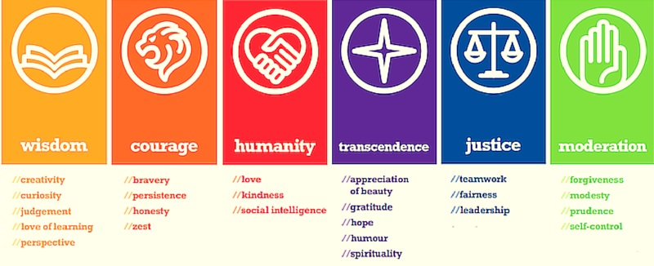
Play to your Strengths:
If you know what you want to achieve, but it requires strengths that don’t come naturally to you—use your signature strength to compensate for some weakness.

