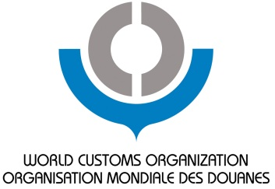

2012 WCO Knowledge Academy for Customs & Trade

WCO Headquarters, Brussels, Belgium
2 – 13 July 2012

A two-week intensive academy focusing on the development of technical skills for Customs and Trade practitioners

With support from:

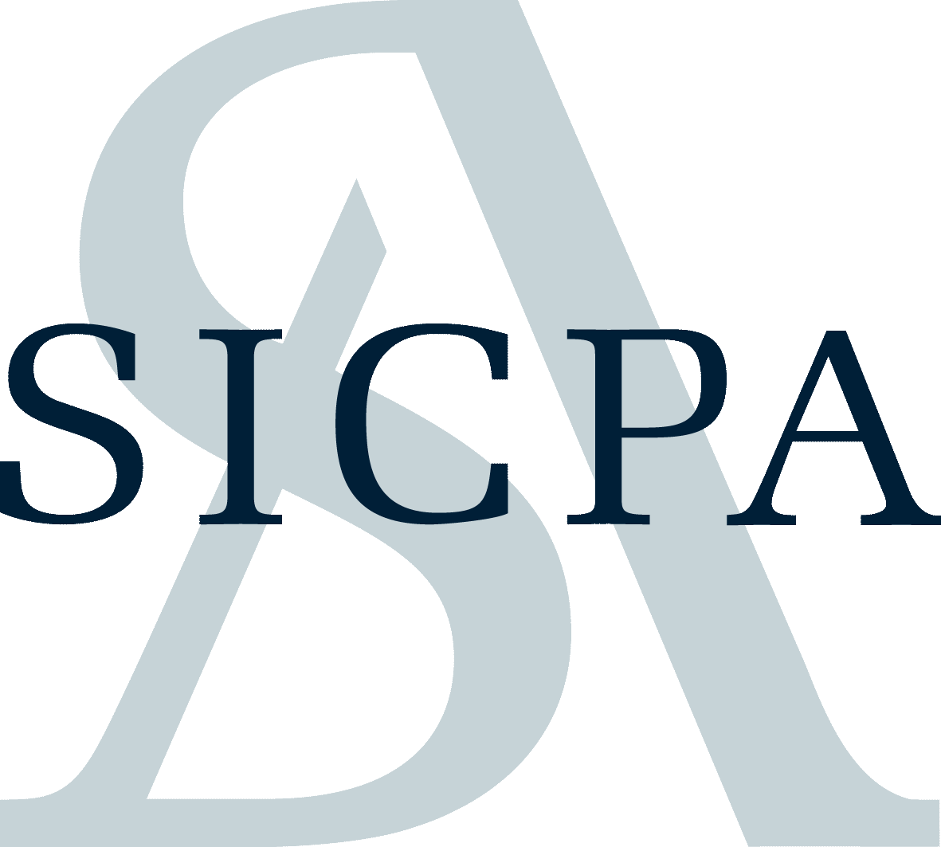

Who will attend?

Customs authorities, the IT sector, the broader business community, governmental and trade organizations, lending institutions, border regulatory agencies, and others involved in the international trade arena

For further information about the Academy
visit the WCO Academy website: http://www.wcoomdtraining.org

For information concerning Sponsorship of the Academy
Please contact greg.pilkington@wcoomd.org

Global Excise Summit hosted by the World Customs Organization and the International Tax and Investment Center
“How are customs instruments involved in the excise world?”
The World Customs Organization (WCO) will hold the Global Excise Summit in cooperation with the International Tax and Investment Center (ITIC) to discuss customs tax administration and enforcement activities aimed at fair and efficient revenue collection.

The collection of revenue has historically been one of the cornerstones of Customs administrations responsibilities and continues to be an area of high importance to our membership. In response to WCO Members’ concerns regarding the collection of fair and accurate revenues, the WCO Revenue Package was developed. Nevertheless, our Members have been seeking a special forum to discuss enforcement issues surrounding commercial fraud and excisable products.

Track 1 – Tariff and Trade affairs Masterclasses

Harmonized System facilitated by Izaak Wind
“How to deal with a commodity when it comes to classification?”
Get the latest information about the HS 2012 amendments and the Committee meetings!

Duration: 15 hours

Basic rules for classifying goods and justification of the classification opinions. Major amendments in HS 2012 and their consequential effects on classifying products. Core fundamentals of the Harmonized System and classification. Sectors covered: High tech, Sets and composite goods, shoes, textiles and sport garments, pre-entry binding tariff information. Case studies will complement the presentations on technical subjects.
- Day one (amendments): brief introduction to the HS and to the General Interpretative Rules; the procedure for amending the HS; the HS 2012 amendments;
- Day 2: High tech, Sets and composite goods
- Day 3 shoes, textiles and sport garments, pre-entry binding tariff information

Guests
- Mr. Austin Valentine, HS Convention, DG TAXUD, European Commission
- Mr. Alexey Shcheglov, WCO Technical Officer, Nomenclature
- Mr. David Kozik, WCO Technical Officer, Nomenclature

Rules of Origin facilitated by Pieter Haesaert
“Why are you so anxious about getting rules of origins Harmonized?”
Get the latest information about the discussions in the committees as well as understand the main decisions made about the BRICS countries

Duration: 10 hours

Overview of the WTO negotiations on the Harmonization of Non-Preferential Rules of Origin (ROO). The costs and advantages of the preferential ROO and the discussion of the technical concepts (“wholly obtained” product, substantial transformation, rules of no drawback, de minimis, direct transport, etc.). The procedural aspects – certification and verification. WCO work on preferential origin.

Guests
- Mr. Atsushi Tanaka, WCO Technical Attaché, Rules of Origin
- 2 experts from private sector i.e. European Industrial federation, ICC, Automobile or Textile industry, Business Europe to answer the question: why are you so anxious about getting rules of origin Harmonized? What are the problems? What are the possible opportunities for the future?

Customs Valuation facilitated by Pieter Haesaert
“Customs valuation and convergence of transfer pricing: latest state-of-play”

Duration: 10 hours

The key concepts of the WTO Customs Valuation Agreement: methods, disputes, WCO instruments (last sale, transfer pricing and royalties). Mechanisms to develop partnership with the trading community. The key concepts of transfer pricing under the OECD Guidelines. Analysis of the stakes and problems of transfer pricing from both tax and Customs points of view. Transfer pricing methods. A comparison between transfer pricing and customs valuation. The concept and major principles of the ATA Carnet system.

Guests
- Mr. Leonardo Macedo, WCO Technical Officer, Customs Valuation
- Ms. Aegyoung Jung, Counsellor, Legal Affairs Division, World Trade Organization
- Mr. Pablo Muñiz, Partner, Van Bael & Bellis
- Mr. Stefaan De Baets, Advisor Transfer Pricing, OECD
- Mr. Dirk Van Stappen, Global Transfer Pricing Services, KPMG
- Ms. Veronique Slachmuylders, Global Transfer Pricing Services, KPMG

Track 2 – Trade Compliance and Facilitation Masterclasses

WCO Data Model facilitated by Sue Probert
Why, What, How?
An introductory course at management level with practical sessions to demonstrate implementation techniques and case studies of success stories

Duration: 15 hours

An introduction to the WCO Data Model, its relationship to a wide range of WCO instruments including the SAFE Framework and the Revised Kyoto Convention, its building blocks and its maintenance procedure. Business process and information modelling: the principles and standards, modelling types and procedures for handling business process and information models. Data Sets: the data sets contained in the Data Model, their structure, their relationship to other standards and their practical implementation. Practical uSAFE of the Data Model (data harmonization and Single Window).

Guests
- Mr. SP Sahu, WCO Technical Officer, WCO Data Model Expert
- Mr. Gareth Lewis, WCO Technical Officer, Trade Facilitation Sub-directorate
- Mr. Mats Wiktor, WCO Technical Attaché, Capacity Building
- GEFEG to present the DM tool

AEO/SAFE facilitated by Joris Zaman
“How have thriving multinationals succeeded to become AEO from different countries?
Learn from successful experiences!
Duration: 10 hours
The concept of the Authorized Economic Operator (AEO) and global trends in its implementation; objectives and benefits of AEO status. Introduction to SAFE Framework of Standards, benefits of its implementation and overview of the latest developments.

Guests
- Ms. Asha Menon, WCO Technical Officer, Trade Facilitation Sub-directorate
- Mr. Simon Royals, WCO Technical Officer, Trade Facilitation Sub-directorate
- Mr. Godfried Smit, International Policy Director, EVO

Risk Management – Be compliant facilitated by TBD
“How to set up a Customs compliance programme in your company?”
Learn from successful businesses how they have implemented a Customs compliance programme!

Duration: 10 hours

Comparison of the key concepts of Customs Risk Management and Private Sector Risk Management. Exchange of experiences in managing risks and exploring the opportunities for
synergizing risk management approaches,

Guests
- Mr. Oguz Onal, WCO Technical Officer, Enforcement
- 2 experts from US companies e.g. Trade compliance managers to exchange on how they have implemented a Customs compliance programme (cf. companies from WCO PSCG website)

Track 3 - Public Sector Masterclasses

Trade Facilitation – facilitated by Milena Budmirovic, WCO Technical Officer, Trade Facilitation Sub-directorate, Compliance & Facilitation Directorate, World Customs Organization
For WCO Members and the private sector

Duration: 10 hours

What are Trade Facilitation and key customs-related TF measures? WCO instruments and tools, how they relate to each other, the Revised Kyoto Convention as the core WCO instrument. WCO Capacity Building initiatives and TF-related CB projects of other international organizations. WTO Trade Facilitation Negotiations and the role of customs, with an insight on Members' experiences.
Guests
- National Customs experts
- Ms. Evdokia Moise-Leeman, Senior Trade Policy Analyst, Trade and Agriculture Directorate, OECD
- Ms. Nora Neufeld, Trade Policy Review Division, WTO
- Mr. Toni Matsudaira, Senior Trade Facilitation Specialist, WTO (tbc)
- Mr. Thierry Piraux, WCO accredited RKC expert, Belgium Customs
- Ms. Annelly Luciano, WCO accredited RKC expert, Dominican Republic Customs
- Mr. John Malone, Head of Sector Valuation and Trade Facilitation, DG TAXUD
- Mr. Andy Badrick, Customs Counselor, Embassy of New Zealand in Brussels
- Mr. Giovanni Bravo Venegas, Economic Counsellor, Mission of Mexico to the EU in Brussels
- Ms. Zwane Gugu Treasure Dlamini, Customs Attaché, Embassy of the Kingdom of Swaziland in Brussels
- Mr. Samson Bilangna, WCO Technical Officer, Procedures and Facilitation Sub-Directorate
- Mr. Satya Prasad Sahu, WCO Technical Officer, Procedures and Facilitation Sub-Directorate
- Ms. Mariya Polner, WCO Research Analyst, Research and Strategies Unit

Risk management – facilitated by Oguz Onal, WCO Technical Officer, Enforcement Sub-directorate, Compliance & Facilitation Directorate, World Customs Organization
For WCO Members only

While the concepts of risk management have been generally understood by Customs, the consistent application of risk management has lacked a common framework and methodology. The objectives of this session include sharing some successful Customs risk management implementation approaches and highlight relevant WCO tools and instruments.

Duration: 10 hours

Guests

- Peter Kovacs, European Commission, Directorate General Taxation and Customs Union (TBC)

Globally Networked Customs – facilitated by Gareth Lewis, WCO Technical Officer, Trade Facilitation Sub-directorate, Compliance & Facilitation Directorate, World Customs Organization
For WCO Members and the private sector

Duration: 10 hours

Connectivity is the WCO theme for 2012 and GNC fits in perfectly – it is a standardized approach to the systematic exchange of information amongst Customs administrations in the interests of better information quality and enhanced risk management. GNC is the first building block of “Customs in the 21st Century” and has been the subject of intense analysis since late 2009. The analytical phase is complete and this is a chance to hear about the key findings.

Guests
- Mr. Mike Weeding, HMRC
- Mr. SP Sahu, WCO Technical Officer, WCO Data Model Expert
- Ms. Marcella Schutte, NL Ministry of Finance

Revenue Package – facilitated by Ian Cremer, WCO Technical Officer, Valuation Sub-directorate, Tariff & Trade Affairs Directorate, World Customs Organization
For WCO Members only

Duration: 10 hours

Presentation and discussions on the Revenue Package programme and the new WCO practical guidelines on Customs Valuation, Origin, Classification and PCA.
Introduction to Revenue Package
Overview of Schedule of tools and instruments
Presentations and discussions on:
- New Practical Guidelines on Valuation Control
- Guidelines for Post-Clearance Audit (PCA)
- Guidelines and National Practices Catalogue on Preferential Origin Verification
- Guidelines and Diagnostic Tool on Tariff Classification Work and Related Infrastructure

Guests
- Experts from the WCO

Global Excise Summit – Monday 2 – Tuesday 3 July 2012
Day 1 – Monday, 2 July
Session I: Opening Session
10:00-10:15 | Introductory Remarks: Mr. Mike Norgrove, Chair of the Summit
10:15-10:30 | Welcome Address: Mr. Kunio Mikuriya, Secretary General, World Customs Organization
10:30-10:50 | Keynote Address – Fundamentals of Excise Duties: Professor Sijbren Cnossen, Maastricht University and University of Pretoria
10:50-11:10 | Keynote Address: WCO Member (Ireland) TBC
11:00-11:30 | Coffee/Tea Break
Session II: Customs Tax Administration
11:30-11:50 | Excise Tax Administration: Assistant Professor Rob Preece (Moderator), Regional Manager: South East Asia, Centre for Customs & Excise Studies, University of Canberra
11:50-12:10 | Protecting Budget Revenues from the Growth of Illicit Trade: Ms. Elizabeth Allen, former senior official, Her Majesty’s Revenue and Customs / Author of The Illicit Trade in Tobacco Products and How to Tackle It
12:10-12:30 | WCO Member Case Study on Revenue Reform (Indonesia) TBC
12:30-12:50 | Developing Tax Systems to Enhance Trust and Voluntary Compliance: Mr. Jeffrey Owens, Former Head of the Centre for Tax Policy and Administration, OECD
12:50-13:00 | Questions & Answers; Wrap-Up
13:00-15:00 | Lunch
Session III: Fair and Efficient Tax Collection
15:00-15:20 | Excise Enforcement: Impact on Revenues on Curbing Illicit Trade: Dr. Janos Nagy, Former Director General, Hungarian Customs
15:20-15:50 | WCO Member Case Study on Motor Spirits: (United Kingdom / Ireland)
15:50-16:10 | WHO Tobacco Protocol and its National Implications: WCO Member Presentation (South Africa)
16:10-16:30 | Taxation of Distilled Spirits: Mr. Mark Baker, Director, International Trade Affairs, Diageo
16:30-16:40 | Questions & Answers; Wrap-Up
16:30-17:00 | Coffee/Tea Break
17:00-17:20 | Taxation of Beer: Mr. Keith Miller, Group Indirect Tax Manager, SABMiller (on behalf of the Brewers of Europe)
17:20-17:40 | WCO Member Case Study (Belgium) TBC
17:40-18:00 | Questions & Answers; Wrap-Up
18:00-20:30 | Gala Dinner Hosted by International Tax and Investment Center
Day 2 – Tuesday, 2 July
Session III: Fair and Efficient Tax Collection (continued)
09:30-09:50 |  | Introductory Remarks: Mr. Daniel A. Witt, President, International Tax and Investment Center
09:50-10:20 |  | Tax Burden and Illicit Trade: Achieving an Optimal Balance: Mr. Adrian Cooper, Chief Executive Officer, Oxford Economics
10:20-10:40 |  | Tools for efficient revenue collection: WCO Revenue Package
10:40-11:00 |  | WCO Member Case Study (Chile)
11:00-11:20 |  | Coffee/Tea Break
11:20-11:40 |  | WCO Member Case Study (Germany)
Session IV: Public-Private Partnership & Technology Solutions
11:40-12:00 |  | Cooperation with the Tobacco Industry (OLAF) TBC
12:00-12:30 |  | Public-Private Partnership / Solution providers to governments:  - Mr. Eric Lequenne, Sales Expert Serialization, Atos  - Mr. Paul Miller, Director of Strategic & Product Marketing, Solutions, De la Rue
12:30-12:50 |  | WCO Member Case Study (New Zeeland) TBC
Session VI: Closing Session
12:50-13:10 |  | Closing Keynote Address: OECD TBC
13:10-13:20 |  | Mr. Mike Norgrove, Chair of the Summit

Tuesday: 3 July 2012

13:00 – 15:00 | Registration
15:00 – 16:30 | Opening Ceremony of the 2012 WCO Knowledge Academy for Customs and Trade
 | Kunio Mikuriya, Secretary General, WCO
 | SICPA
 | L-3 Communications
16:30 – 17:00 | Refreshment and contact break
17:00 – 18:00 | Introduction of Trainers, Topics, Housekeeping
18.00 – 20:00 | Networking cocktail sponsored by:

 | Day 1: Wednesday 4 July
09:00 – 09:30 |  | Registration
09:30 – 10:00 |  | Plenary session –
 | Day 1: Wednesday 4 July
10:00 – 17:30 |  | Individual Learning Tracks
 | Learning Track 1  Facilitated by Izaak Wind | Learning Track 2  Facilitated by Sue Probert | Learning Track 3
10:00 – 11:00 | Harmonized System 2012  Information about the 2012 amendments | WCO Data Model  SP Sahu, WCO Technical Officer  Gareth Lewis, WCO Technical Officer | Trade Facilitation  Milena Budimirovic, WCO Technical Officer
11:00 – 11:30 |  | Refreshment and contact break
11:30 – 12:30 | Harmonized System 2012 | WCO Data Model | Trade Facilitation
12:30 – 14:00 |  | Lunch
14:00 – 16:00 | Harmonized System 2012 | WCO Data Model | Trade Facilitation
16:00 – 16:30 |  | Refreshment and contact break
16:30 – 17:30 | Harmonized System 2012  Information about the 2012 amendments | WCO Data Model | Trade Facilitation

 | Day 2: Thursday 5 July
09:30 – 17:30 |  | Individual Learning Tracks
 | Learning Track 1  Facilitated by Izaak Wind | Learning Track 2  Facilitated by Sue Probert | Learning Track 3
09:30 – 11:00 | Harmonized System 2012  Focus on High tech | WCO Data Model | Trade Facilitation
11:00 – 11:30 |  | Refreshment and contact break
11:30 – 12:30 | Harmonized System 2012  Focus on High tech | WCO Data Model | Trade Facilitation
12:30 – 14:00 |  | Lunch
14:00 – 16:00 | Harmonized System 2012  Focus on Sets and composite goods | WCO Data Model | Trade Facilitation
16:00 – 16:30 |  | Refreshment and contact break
16:30 – 17:30 | Harmonized System 2012  Focus on Sets and composite goods | WCO Data Model | Trade Facilitation
 | Day 3: Friday, 6 July
09:00 – 09:30 |  | Registration
09:30 – 17:30 |  | Individual Learning Tracks
 | Learning Track 1  Facilitated by Izaak Wind | Learning Track 2  Facilitated by Sue Probert | Learning Track 3  Open to WCO members only
09:30 – 11:00 | Harmonized System 2012  Focus on shoes, textiles and sports garments | WCO Data Model | Risk Management  Oguz Onal, WCO Technical Officer
11:00 – 11:30 |  | Refreshment and contact break
11:30 – 12:30 | Harmonized System 2012  Focus on shoes, textiles and sports garments | WCO Data Model | Risk Management
12:30 – 14:00 |  | Lunch
14:00 – 16:00 | Harmonized System 2012  Focus on Pre-Entry Binding Tariff Information | WCO Data Model | Risk Management
16:00 – 16:30 |  | Refreshment and contact break
16:30 – 17:30 | Harmonized System 2012  Focus on Pre-Entry Binding Tariff Information  WCO Tariff and trade specialist | WCO Data Model | Risk Management
 | Day 4: Saturday 7 July
09:00 – 17:00 |  | Field Trip – Port of Antwerp operations
 | Sunday, 8 July
 | Free time | No planned activities

 | Day 5: Monday, 9 July
09:00 – 09:30 |  | Registration
09:30 – 10:00 |  | Plenary session –
10:00 – 17:30 |  | Individual Learning Tracks
 | Learning Track 1  Facilitated by Pieter Haesaert | Learning Track 2  Facilitated by Joris Zaman | Learning Track 3
10:00 – 11:00 | Rules of Origin  Atsushi Tanaka, WCO | AEO/SAFE  Asha Menon, WCO | Globally Networked Customs  Gareth Lewis, WCO Technical Officer
11:00 – 11:30 |  | Refreshment and contact break
11:30 – 12:30 | Rules of Origin | AEO/SAFE | Globally Networked Customs
12:30 – 14:00 |  | Lunch
14:00 – 16:00 | Rules of Origin | AEO/SAFE  Speaker from the Private sector | Globally Networked Customs
16:00 – 16:30 |  | Refreshment and contact break
16:30 – 17:30 | Rules of Origin  Speaker from the Private sector | AEO/SAFE  Speaker from the Private sector | Globally Networked Customs
 | Day 6: Tuesday 10 July
09:30 – 17:30 |  | Individual Learning Tracks
 | Learning Track 1  Facilitated by Pieter Haesaert | Learning Track 2  Facilitated by Joris Zaman | Learning Track 3  Facilitated by
09:30 – 11:00 | Rules of Origin  Speaker from the Private sector | AEO/SAFE | Globally Networked Customs
11:00 – 11:30 |  | Refreshment and contact break
11:30 – 12:30 | Rules of Origin  TBD, UNCTAD | AEO/SAFE | Globally Networked Customs
12:30 – 14:00 |  | Lunch
14:00 – 16:00 | Rules of Origin | AEO/SAFE | Globally Networked Customs
16:00 – 16:30 |  | Refreshment and contact break
16:30 – 17:30 | Rules of Origin | AEO/SAFE | Globally Networked Customs

 | Day 7: Wednesday, 11 July
09:00 – 09:30 | Registration
09:30 – 17:30 |  |  | Individual Learning Tracks
 | Learning Track 2  Facilitated by Pieter Haesaert | Learning Track 2  Facilitated by TBD |  | Learning Track 3  Open to WCO members only
09:30 – 11:00 | Customs Valuation  Leonardo Macedo, WCO | Risk Management |  | Revenue Package  Ian Cremer, WCO Technical Officer
11:00 – 11:30 | Refreshment and contact break
11:30 – 12:30 | Customs Valuation | Risk Management |  | Revenue Package
12:30 – 14:00 | Lunch
14:00 – 16:00 | Customs Valuation | Risk Management  Martin Brown, UPS |  | Revenue Package
16:00 – 16:30 |  |  | Refreshment and contact break
16:30 – 17:30 | Customs Valuation | Risk Management  Risk manager from Honeywell |  | Revenue Package
 | Day 8: Thursday, 12 July
09:30 – 17:30 |  |  | Individual Learning Tracks
 | Learning Track 2  Facilitated by Pieter Haesaert | Learning Track 2  Facilitated by TBD |  | Learning Track 3  Open to WCO members only
09:30 – 11:00 | Customs Valuation  Mr. Stefaan De Baets,  Advisor Transfer Pricing, OECD  - Basics transfer pricing and OECD  guidelines  - Comparison and differences TP/customs valuation  - Convergence | Risk Management |  | Revenue Package  Ian Cremer, WCO Technical Officer
11:00 – 11:30 |  |  | Refreshment and contact break
11:30 – 12:30 | Customs Valuation  Mr. Dirk Van Stappen,  Global Transfer Pricing Services, KPMG | Risk Management  Speaker from the Private sector |  | Revenue Package
12:30 – 14:00 |  |  | Lunch
14:00 – 16:00 | Customs Valuation  Ms. Veronique Slachmuylders, Global Transfer Pricing Services, KPMG | Risk Management  Speaker from the Private sector |  | Revenue Package
16:00 – 16:30 |  |  | Refreshment and contact break
16:30 – 17:30 | Customs Valuation | Risk Management |  | Revenue Package

Day 9: Friday, 13 July
09:30 – 10:45 | Plenary
10:45 – 11:30 | Refreshment and contact break
11:30 – 13:00 | Closing Ceremony / Certificates  Sergio Mujica, Deputy Secretary General, WCO

