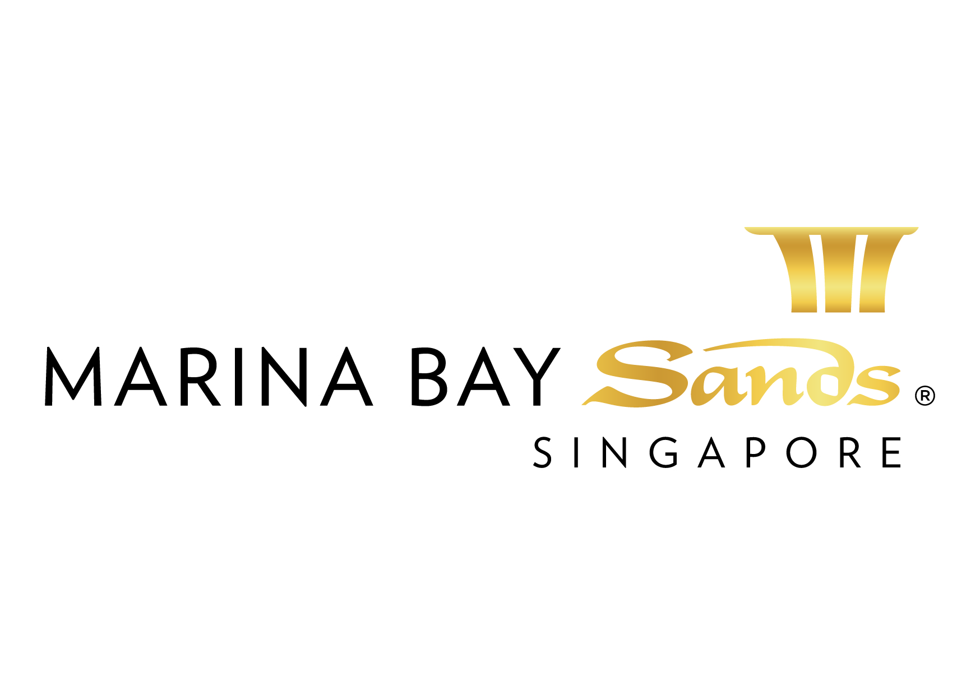

TELECOMMUNICATIONS INSTRUCTIONS & CONDITIONS - 2015

INSTRUCTIONS AND CONDITIONS

- The Sands Expo & Convention Centre and Sands Event Services shall not be liable for, and hereby released from, any special, indirect, incidental, or consequential damage; including without limitation, the following: lost profits, damage to business reputation, lost opportunity or commercial loss of any kind to the customer which results from the use (or the inability to use) any of the services or equipment which is contemplated herein, or from the breach by the SECC, Sands Event Services, or any of their employees, agents or contractors.

- Cancellation: All orders are subject to a 50% cancellation fee if cancelled within 21 calendar days prior to show opening date.

- All charges are subject to change without prior notice.

ADDITIONAL CHARGES/FEES:

- Call Detail Charges – Local call, operator-assisted, and 800 calls will be charged a minimum of $1.00 per call. All long-distance and international calls are charged based on the prevailing rates.

- Instruments – Instruments with attachment line must be returned to the MICE Customer Service Desk within one hour following the close of the event. Exhibitors who do not return their instruments will be charged: $300 for single-line instruments and $1000 for multi-line and polycom instruments.

- Labour Charges – Labour between the hours of 8:00 AM and 10:00 PM Monday – Sunday, including holidays (minimum 1 hour work) will be at the Straight Time labour rate. After 8 hours of work, Overtime labour rate applies. Any work from 10:01 PM – 07:59 AM, will be at the Midnight labour rate.

LABOR RATES: Straight Time = $100/hour Overtime = $150/hour Midnight = $300/hour

Prices, Policies, and Procedures Subject to Change without prior notice.

GST Registration No. M90364464C.

LAST DAY TO RECEIVE ADVANCE RATE IS 17 AUGUST 2015
FORM 18
TELECOMMUNICATIONS SERVICES ORDER FORM - 2015
E-mail or fax forms to:
MARINA BAY SANDS – ATTN: SANDS EXPO & CONVENTION CENTRE – MICE SERVICE CENTRE
10 BAYFRONT AVENUE SINGAPORE 018956
P: +65 6688-3888 F: +65 6688-3889 E: secc@marinabaysands.com
Please indicate total number of pages faxed to ensure complete order was received.
EVENT NAME: HIMSS Asia Pac 15 Digital Healthcare Week |  |  | EVENT DATES: 07-10 September 2015 |  |  | BOOTH # / MTG. ROOM #
EXHIBITING CO. NAME: |  |  | HALL LOCATION: Level 5, Ballroom A-H
STREET ADDRESS: |  | CITY: |  |  | STATE: | ZIP:
TELEPHONE: |  | FAX: |  |  | E-MAIL:
ORDERED BY:  (Print Name) |  |  |  | SIGNATURE:
IMPORTANT: SANDS EVENT SERVICES IS THE EXCLUSIVE TELECOMMUNICATIONS SERVICES PROVIDER AT SECC. NO OTHER PROVIDER OR TELECOMMUNICATIONS SERVICE WILL BE ALLOWED ON THE SHOW FLOOR AT ANY TIME. TO RECEIVE ADVANCE DISCOUNT PRICES (UNLESS OTHERWISE STATED), SANDS EVENT SERVICES MUST RECEIVE YOUR ORDER WITH FULL PAYMENT BY 5 PM UCT 21 CALENDAR DAYS PRIOR TO SHOW OPENING DATE TO ENSURE AVAILABILITY. ALL OTHER ORDERS WILL BE PROCESSED AT THE STANDARD OR ON-SITE RATE. NO CREDITS WILL BE ISSUED ON SERVICES INSTALLED AS ORDERED EVEN THOUGH NOT USED. ALL ORDERS ARE SUBJECT TO A 7% GST & CANCELLATION FEE. REVIEW INVOICE PRIOR TO DEPARTURE. FOR CREDIT CONSIDERATION, ALL SERVICE CONCERNS MUST BE MADE KNOWN DURING THE SHOW.

FORM INFORMATION: (Please read carefully)
- BEFORE TELEPHONE LINES ARE INSTALLED, A CREDIT CARD MUST BE ON FILE. PLEASE FILL OUT THE “CREDIT CARD ATHORIZATION FORM”. THE CREDIT CARD WILL BE USED TO INVOICE TELEPHONE CALLS THAT EXCEED THE DEPOSIT OR TO CREDIT ANY UNUSED PORTION OF YOUR DEPOSIT.
- PRE-PLANNING CAN SAVE YOU MONEY. Telephone lines are dropped with the main power drop into booth. PLEASE INDICATE ALL TELEPHONE LINE LOCATIONS BY FILLING OUT THE LOCATION GRID. Failure to notify Sands Event Services of telephone location will result in a charge on a time and material basis to relocate line.
- Telephone service which is pre-ordered cannot be guaranteed prior to one day before event opening due to temporary conditions which exist during set up. Orders that are placed after the cut-off date will be handled on a first-come, first-serve basis. Orders placed at show site cannot be guaranteed. Instruments should be picked up at MICE Customer Service Desk.
- Instruments will not be delivered to your booth. Instruments should be picked up at MICE Customer Service Desk.
ITEM | QTY | ADVANCED RATE | STANDARD RATE | ON-SITE RATE | SUBTOTAL  (QTY X PRICE)
NORTEL IP PHONE  (LOCAL CALLS ONLY/ELECTRICAL SOCKET INCLUDED) |  | $221 | $260 | $306
NORTEL IP PHONE  (INTERNATIONAL ACCESS/ ELECTRICAL SOCKET INCLUDED) |  | $238  Excludes $200 deposit | $280  Excludes $200 deposit | $329  Excludes $200 deposit
ANALOGUE VOICE/ FAX LINE (LOCAL TRANSMISSION ONLY, HANDSET/ FAX MACHINE NOT INCLUDED) |  | $221 | $260 | $306
ANALOGUE VOICE/ FAX LINE (INTERNATIONAL TRANSMISSION, HANDSET/ FAX MACHINE NOT INCLUDED) |  | $238  Excludes $200 deposit | $280  Excludes $200 deposit | $329  Excludes $200 deposit
ANALOGUE LINE FOR CREDIT CARD OR NETS SERVICE  (CREDIT CARD/ NETS MACHINE NOT INCLUDED. The machine needs to prefix a digit 9 in front for outgoing) |  | $221 | $260 | $306
ISDN2 DIGITAL LINE  WITH NETWORK TERMINAL (NT) |  | $255 | $300 | $353
NORTEL IP BASED TELECONFERENCING SYSTEM  with phone line – (IDD charges apply based on  consumption inclusive of SGD200 deposit) |  | $442 | $520 | $612
 |  |  | TOTAL
 |  |  | GST 7%
 |  |  | GRAND TOTAL
NOTE: A Service Location Plan (Form 3) must be submitted to process electrical orders.
Preferred handover date & time of the equipment and/or service requested should also be included.

ALL SERVICES PROVIDED BY SANDS EVENT SERVICES

All orders are subject to a cancellation fee if CANCELLED within 21 calendar days prior to show opening date. All services delivered on site cannot be cancelled nor be refunded. All prices are subject to change without prior notice.

PAYMENT MODE Credit card information will be used to guarantee the service request on this order form. (Will be used for any and all Sands Event Services you order in addition to those listed on this form.)

Cheque/ Telegraphic No. _________________________ MAKE PAYABLE TO: MARINA BAY SANDS PTE LTD. MUST BE RECEIVED 14 DAYS PRIOR TO EVENT START DATE.
Credit Card Payment:
Please fill up the Credit Authorisation Form and submit together with front and back of the credit card.
Note: To omit the 3 digit CVV/CVC numbers at the back of the credit card due to security issues.

Cash (only applicable for onsite orders)

Telegraphic Transfer:
Please make payment to:
Bank Name: DBS Bank Ltd
A/C No.: 003-909346-2
A/C Name: Marina Bay Sands Pte Ltd
Swift Code: DBSSSGSG
Reference: Please include the event/event date during Telegraphic Transfer. Failure to do so will result with the wire transfer not properly crediting to your event account.
NOTE: Organisation will be responsible for the payment of all charges incurred from the bank.

Cheque Payment:
All cheques should be crossed and made payable to
Marina Bay Sands Pte Ltd

All payments must be sent directly to:
Marina Bay Sands Pte Ltd
Accounts Receivable
Finance Non-Gaming Department
10 Bayfront Avenue
Singapore 018956
Reference: Please include the show name at the back of the
cheque. Failure to do so will result in cheque not properly
crediting to your event account.

Prices, Policies, and Procedures Subject to Change without prior notice. GST Registration No. M90364464C

