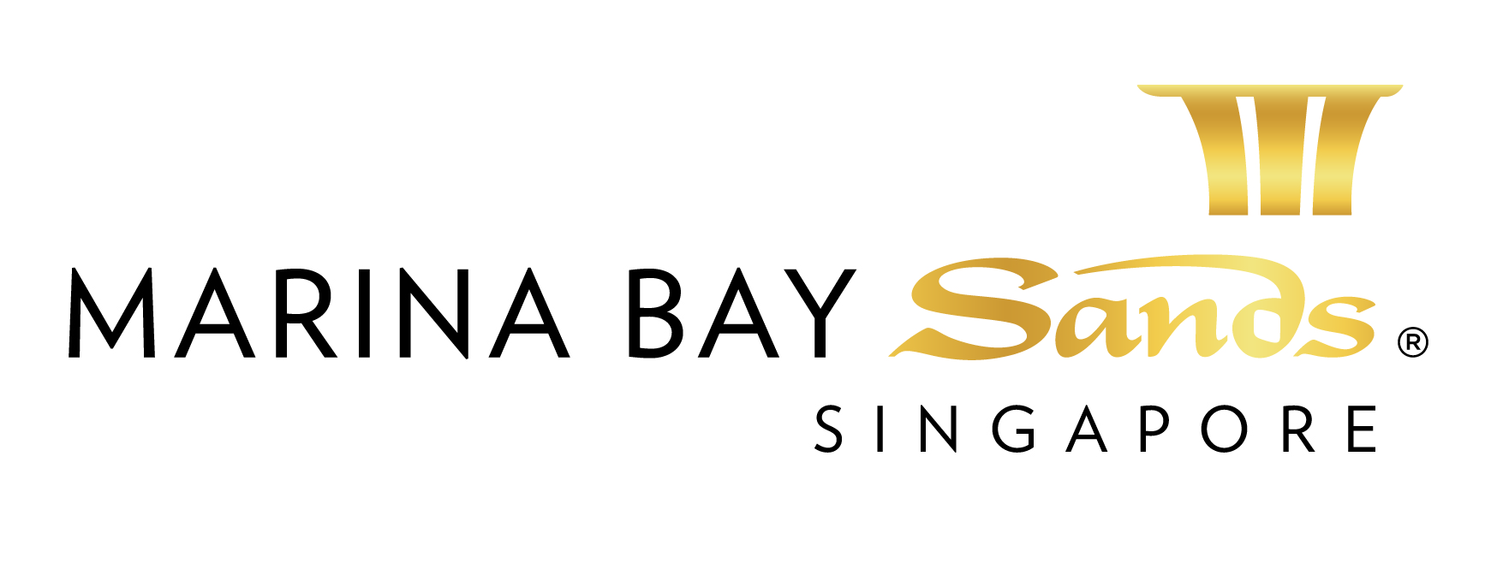 SERVICE LOCATION PLAN – 2015
FORM 3

To assist us in placing your services in the proper location, please utilize this service location plan. If you send us your own floor plan, please make sure that it includes all of the information that we have indicated on this plan.
The service ordered will be dropped from the exhibition hall ceiling vertically above the booth area or obtained from the nearest service closest of the booth on floor level. The termination point will be as close as possible to the required location (s). The service will be terminated at floor level with the appropriate termination. Any horizontal running of the service is subject to a separate charge with quotation on actual work involved.

ELECTRICAL SERVICES: TELECOMMUNICATION SERVICES:
- Indicate main power location. Indicate main telephone line termination location.
- Indicate additional outlet locations with rating
- Indicate lighting connection point (Indicate wattage
or amperage required at each location.) Indicate extension phone line termination locations.

COMPRESSED AIR/WATER OUTLETS: INTERNET SERVICES:
- Indicate these locations (for island booths) Indicate location of internet port termination location.
By writing “Air/Water” at appropriate location.
(with capacity of the supply rating)

RIGGING/HANGING APPLICATIONS:
- You must submit a detailed plan for hanging applications.
Please see page 4 or contact us with questions regarding hanging signs, truss, or use of motorized hoist(s).
- Detach the Service Location Plan and send with your order form(s).
- Please complete this information for ease of booth identification.

EVENT NAME: HIMSS Asia Pac 15 Digital Healthcare Week |  | EVENT DATES: 07-10 September 2015
EXHIBITING CO. NAME: |  | BOOTH #:
CONTACT PERSON ON SITE: | LOCAL CONTACT NO. (IF ANY) | EMAIL CONTACT:
PREFERRED SERVICE ACTIVATION / HAND-OVER SCHEDULE: ( Time / Date ) | Note:  All services provided under this standard service order forms are intended to be used by the customer for a continuous rental period of not more than seven (7) days unless otherwise stated. The Centre reserves the right to apply a surcharge for early activation and/or extended usage of the services. A surcharge is also applicable if the customer requests the Centre to handover and/or activates the service outside the license period.

Please indicate and mark up the location of the service in the diagram below.
Scale: 1 square = square meter OR Other:

INDICATE ADJACENT BOOTH NO. THIS DIRECTION _______

INDICATE ADJACENT
BOOTH NO.
THIS DIRECTION
___

INDICATE ADJACENT
BOOTH NO.
THIS DIRECTION
__

INDICATE ADJACENT BOOTH NO. THIS DIRECTION ______________

