LAST DAY TO RECEIVE ADVANCE RATE IS 17 AUGUST 2015
FORM 16B
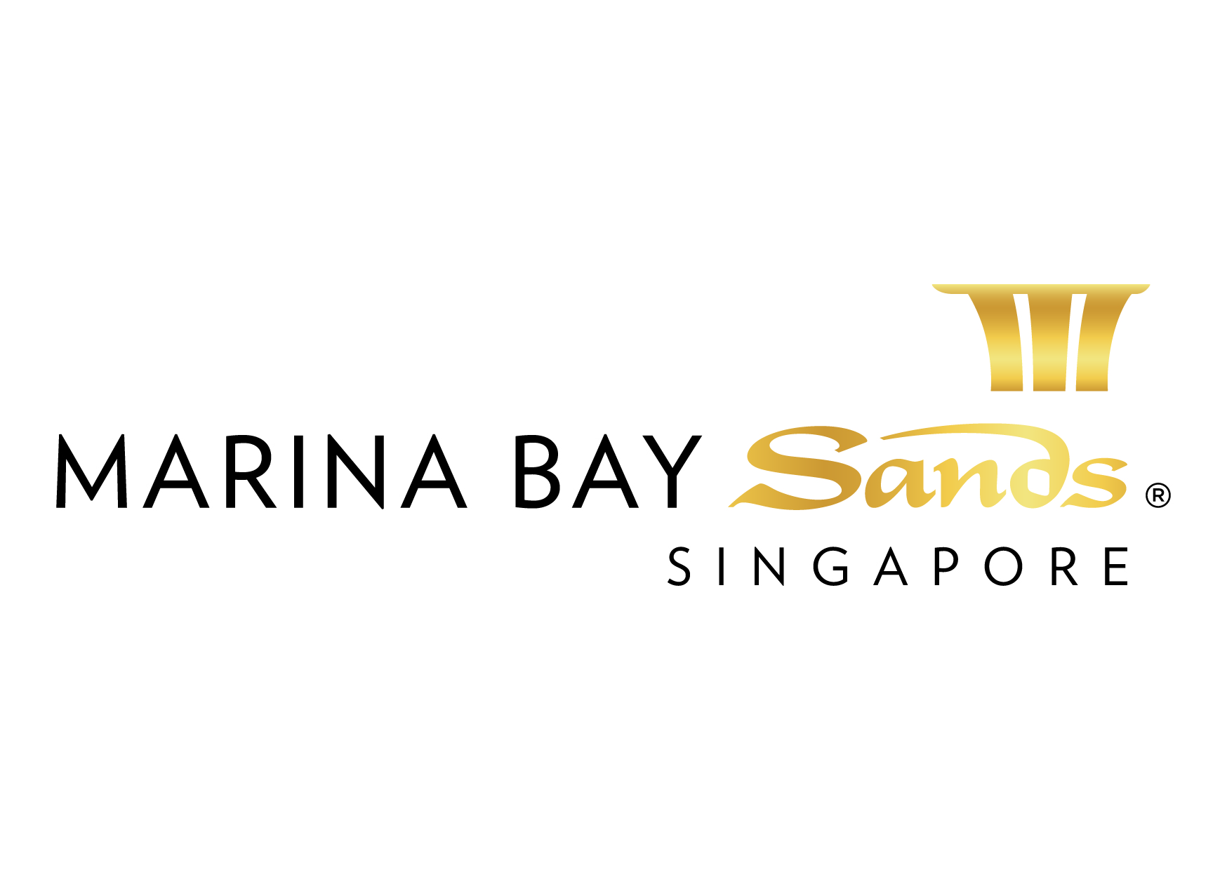 | RIGGING: HANGING SIGN SERVICES ORDER FORM - 2015  E-mail or fax forms to:  MARINA BAY SANDS – ATTN: SANDS EXPO & CONVENTION CENTRE – MICE SERVICE CENTRE  10 BAYFRONT AVENUE SINGAPORE 018956  P: +65 6688-3888 F: +65 6688-3889 E: secc@marinabaysands.com  Please indicate total number of pages faxed to ensure complete order was received.
EVENT NAME: HIMSS Asia Pac 15 Digital Healthcare Week |  |  | EVENT DATES: 07-10 September 2015 |  |  | BOOTH # / MTG. ROOM #
EXHIBITING CO. NAME: |  |  | HALL LOCATION: Level 5, Ballroom A-H
STREET ADDRESS: |  | CITY: |  |  | STATE: | ZIP:
TELEPHONE: |  | FAX: |  |  | E-MAIL:
ORDERED BY:  (Print Name) |  |  |  | SIGNATURE:
BY SIGNING AND DELIVERING THIS FORM TO SECC, CUSTOMER AGREES TO ALL TERMS AND CONDITIONS PRINTED ON THIS FORM.
IMPORTANT: SANDS EVENT SERVICES IS THE EXCLUSIVE HANGING SIGN/RIGGING PROVIDER AT SECC. NO OTHER PROVIDER OR HANGING SIGN/RIGGING SERVICE WILL BE ALLOWED ON THE SHOW FLOOR AT ANY TIME. TO RECEIVE ADVANCE DISCOUNT PRICES (UNLESS OTHERWISE STATED), SANDS EVENT SERVICES MUST RECEIVE YOUR ORDER WITH FULL PAYMENT BY 5 PM UCT 21 CALENDAR DAYS PRIOR TO SHOW OPENING DATE TO ENSURE AVAILABILITY. ALL OTHER ORDERS WILL BE PROCESSED AT THE ON-SITE RATE. NO CREDITS WILL BE ISSUED ON SERVICES INSTALLED AS ORDERED EVEN THOUGH NOT USED. ALL ORDERS ARE SUBJECT TO A 7% GST & CANCELLATION FEE. REVIEW INVOICE PRIOR TO DEPARTURE. FOR CREDIT CONSIDERATION, ALL SERVICE CONCERNS MUST BE MADE KNOWN DURING THE SHOW.

INFORMATION AND INSTRUCTIONS – HANGING ITEMS
- Sands Event Services is responsible for hanging, assembly, and operation of all electrical and non-electrical hanging items within the Sands Expo & Convention Centre. Display companies or exhibitor’s representative may supervise these activities.
- All services provided under this standard service order forms are intended to be used by the customer for a continuous rental period of not more than seven (7) days unless otherwise stated. The Centre reserves the right to apply a surcharge for early activation and/or extended usage of the services. A surcharge is also applicable if the customer requests the Centre to handover the service outside the license period.
- For safety reasons, all signs will be hung by Marina Bay Sands in-house rigging team.
- Items must include blueprints or drawings with detailed information, which must include orientation in booth, pick points for hanging, and assembly instructions.
- All items must be in working order, structurally sound, and in accordance with applicable codes.
- There will be a 30% service charge for orders for hanging applications that are placed on site.
- IMPORTANT: You should contact your general service contractor for shipping instructions for all hanging items.

BASIC BANNER/SIGN PACKAGES
ITEM | QTY | ADVANCED RATE | STANDARD RATE | ON-SITE RATE | TOTAL  (QTY X PRICE)
Signware Banner Hanging Service (applicable to banners produced by Marina Bay Sands only)  A lead time of 10 working days required. Wire and supporting tube included. Maximum size 4m (L) weight less than 20Kg. Production of banner excluded. |  | $200 | $235 | N.A.
Single-sided digital vinyl prints for signware banner (per sqm). A lead time of 10 working days required, artwork to be provided by client. |  | $80 /m² | $94 /m² | N.A.
Double-sided digital vinyl prints for signware banner (per sqm) A lead time of 10 working days required, artwork to be provided by client. |  | $110 /m² | $129 /m² | N.A.
Maxima backdrop 3m (height) |  | $100 /m run | $118 /m run | $138 /m run
Banners hanging charge for self-bringing banner (Total weight less than 20kg and smaller than 4MX4M in size) |  | $425 | $500 | $715
SIGN SIZE/CONFIGURATION |  |  | TOTAL
ELECTRICAL NON-ELECTRIC SIGN LIGHTING TRUSS OTHER |  |  | GST 7%
POWER REQUIREMENTS: ____________ AMP OR WATTS ___________ VOLTAGE |  |  | GRAND TOTAL

PRINT, PLOTS, OR DRAWINGS MUST BE PROVIDED

LABOUR AND EQUIPMENT RATES FOR HANGING APPLICATIONS

LABOUR RATES (applicable to exhibition halls only):

*STRAIGHT TIME = $50/hour, Mon – Sun including holidays, 8 AM to 10 PM, minimum of 4 hours

*OVERTIME = $75/hour, after 8 hours of work

*MIDNIGHT = $150/hour, any work from 10:01 PM to 07:59 AM
Labour to dismantle will be based on half of the installation time and will be automatically applied to your invoice. Supervision – A 20% supervision fee will be charged when Sands Event Services personnel are not working under the direct supervision of the exhibitor or exhibitor representative.

SERVICE REQUESTED: Date: _________________________ Time: ___________________ No. of Persons __________ (3 person minimum for rigging)

SEE SANDS EVENT SERVICES “SCOPE OF WORK” ON PAGE 4 FOR INFORMATION ON EXCLUSIVE LABOUR SERVICES.

EQUIPMENT (without operator, minimum 4 hrs usage)
BOOMLIFT - $50 PER HOUR SCISSOR LIFT - $30 PER HOUR ELECTRIC AERIAL WORK PLATFORM - $25 PER HOUR

- Please provide drawing with detailed information, including engineering approval, booth dimensions, orientation, pick points, and assembly instructions.
- In order for us to hang your sign to the proper height, please provide the measurements from the floor to the top of the sign.
- MBS Event Services reserves the right to refuse to hang any application if they deem it unsafe, for specific questions concerning hanging applications, please call +65 6688-3888.

All orders are subject to a cancellation fee if CANCELLED within 21 calendar days prior to show opening date. All services delivered on site cannot be cancelled nor be refunded. All prices are subject to change without prior notice.

PAYMENT MODE Credit card information will be used to guarantee the service request on this order form. (Will be used for any and all Sands Event Services you order in addition to those listed on this form.)

Cheque/ Telegraphic No. _________________________ MAKE PAYABLE TO: MARINA BAY SANDS PTE LTD. MUST BE RECEIVED 14 DAYS PRIOR TO EVENT START DATE.
Cheque Payment:
Credit Card Payment:
Please fill up the Credit Authorisation Form and submit together with front and back of the credit card.
Note: To omit the 3 digit CVV/CVC numbers at the back of the credit card due to security issues.

Cash (only applicable for onsite orders)

Telegraphic Transfer:
Please make payment to:
Bank Name: DBS Bank Ltd
A/C No.: 003-909346-2
A/C Name: Marina Bay Sands Pte Ltd
Swift Code: DBSSSGSG
Reference: Please include the event/event date during Telegraphic Transfer. Failure to do so will result with the wire transfer not properly crediting to your event account.
NOTE: Organisation will be responsible for the payment of all charges incurred from the bank.

All cheques should be crossed and made payable to
Marina Bay Sands Pte Ltd

All payments must be sent directly to:
Marina Bay Sands Pte Ltd
Accounts Receivable
Finance Non-Gaming Department
10 Bayfront Avenue
Singapore 018956
Reference: Please include the show name at the back of the
cheque. Failure to do so will result in cheque not properly
crediting to your event account.

Prices, Policies, and Procedures Subject to Change without prior notice. GST Registration No. M90364464C

