LAST DAY TO RECEIVE ADVANCE RATE IS 17 AUGUST 2015
FORM 16A
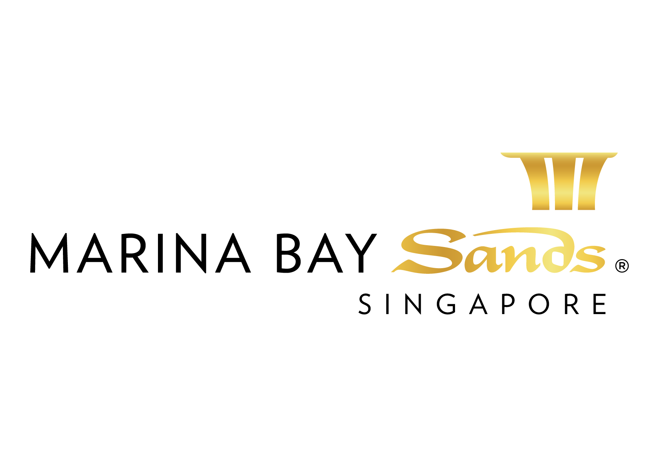 | RIGGING / HANGING: TRUSS / THEATRICAL LIGHTING RENTAL ORDER FORM – 2015  E-mail or fax forms to:  MARINA BAY SANDS – ATTN: SANDS EXPO & CONVENTION CENTRE – MICE SERVICE CENTRE  10 BAYFRONT AVENUE SINGAPORE 018956  P: +65 6688-3888 F: +65 6688-3889 E: secc@marinabaysands.com  Please indicate total number of pages faxed to ensure complete order was received.
EVENT NAME: HIMSS Asia Pac 15 Digital Healthcare Week |  |  | EVENT DATES: 07-10 September 2015 |  |  | BOOTH # / MTG. ROOM #
EXHIBITING CO. NAME: |  |  | HALL LOCATION: Level 5, Ballroom A-H
STREET ADDRESS: |  | CITY: |  |  | STATE: | ZIP:
TELEPHONE: |  | FAX: |  |  | E-MAIL:
ORDERED BY:  (Print Name) |  |  |  | SIGNATURE:
BY SIGNING AND DELIVERING THIS FORM TO SECC, CUSTOMER AGREES TO ALL TERMS AND CONDITIONS PRINTED ON THIS FORM.
IMPORTANT: SANDS EVENT SERVICES IS THE EXCLUSIVE HANGING SIGN/RIGGING PROVIDER AT SECC. NO OTHER PROVIDER OR HANGING SIGN/RIGGING SERVICE WILL BE ALLOWED ON THE SHOW FLOOR AT ANY TIME. TO RECEIVE ADVANCE DISCOUNT PRICES (UNLESS OTHERWISE STATED), SANDS EVENT SERVICES MUST RECEIVE YOUR ORDER WITH FULL PAYMENT BY 5 PM UCT 21 CALENDAR DAYS PRIOR TO SHOW OPENING DATE TO ENSURE AVAILABILITY. ALL OTHER ORDERS WILL BE PROCESSED AT THE STANDARD OR ON-SITE RATE. NO CREDITS WILL BE ISSUED ON SERVICES INSTALLED AS ORDERED EVEN THOUGH NOT USED. ALL ORDERS ARE SUBJECT TO A 7% GST & CANCELLATION FEE. REVIEW INVOICE PRIOR TO DEPARTURE. FOR CREDIT CONSIDERATION, ALL SERVICE CONCERNS MUST BE MADE KNOWN DURING THE SHOW.

ALLOW US TO ASSIST YOU WITH ALL OF YOUR PRODUCTION REQUIREMENTS. FROM THE SMALLEST TO THE LARGEST, WE CAN PROVIDE IT ALL!
Motorized Hoists / Trussing Robotics and Conventional Lighting Dimmers and Controls
No Shipping Costs for In-house Products Fully Trained and Professional Staff Lighting Design Services

Please check this box if you require professional solution for your production requirements in your event. Our professional production team will approach you for further assistance.
DESCRIPTION OF SERVICE | QTY | ADVANCED RATE | STANDARD RATE | ON-SITE RATE | SUBTOTAL
- 300mm x 300mm x 3.05mL(10 ft) Square Aluminium Truss  (include labour for assembly, lifting, derig during normal working hours) |  | $240 | $282 | $332
- 300mm x 300mm x 2.44 mL(8 ft) Square Aluminium Truss  (include labour for assembly, lifting, derig during normal working hours) |  | $200 | $235 | $277
- 300mm x 300mm x 1.52 mL(5 ft) Square Aluminium Truss  (include labour for assembly, lifting, derig during normal working hours) |  | $120 | $141 | $166
- 300mm x 300mm Truss connection block  (include labour for assembly, lifting, derig during normal working hours) |  | $80 | $94 | $111
- Chain Master 1 ton Motor Hoist (c/w motor controller)  (inclusive of use of rigging eyelet, labour for assembly, lifting, de-rig during normal working hours) |  | $650 | $765 | $900
- Rigging Point (inclusive of use of rigging eyelet, 1 ton manual chain hoist, labour for assembly, lifting, derig during normal working hours) |  | $450 | $529 | $623
- Hook Up ONLY (inclusive of use of rigging eyelet, and labour for lifting, derig during normal working hours only, manual chain hoist and accessories to be provided by customer) |  | $200 | $235 | $277
RIGGING WORK SCHEDULE  Please indicate in the box below for the rigger booking schedule and contact person requested by the customer to carry out the work above. ‘Normal Working Hours’ stated in the order form above refers to the licensed move-in period of the event and do not apply to overnight work. Marina Bay Sands reserves the right to charge customer for additional labour if work cannot commence as per schedule due to no show of the customer or delay in customer’s own setup schedule. Rescheduling will be allocated based on the next available slot if there is a no show of 30minutes or more from the stipulated schedule. On-site or overtime charges will prevail. No refund is allowed. |  |  |  | TOTAL
 |  |  |  | GST 7%
 |  |  |  | GRAND TOTAL

Please check this box if you have sent your booth visuals to us.

Rigger Booking Schedule
Customer Company Name | Contact Person On Site | Rigger Location/ Booth | Preferred handover date & time  (Subject to final schedule of Marina Bay Sands)
Email Contact | Local Contact No. (if any)

Special Request (if any)

All orders are subject to a cancellation fee if CANCELLED within 21 calendar days prior to show opening date. All services delivered on site cannot be cancelled nor be refunded.
All prices are subject to change without prior notice. All services provided under this standard service order forms are intended to be used by the customer for a continuous rental period of not more than seven (7) days unless otherwise stated. The Centre reserves the right to apply a surcharge for early activation and/or extended usage of the services. A surcharge is also applicable if the customer requests the Centre to handover the service outside the license period.

PAYMENT MODE Credit card information will be used to guarantee the service request on this order form. (Will be used for any and all Sands Event Services you order in addition to those listed on this form.)
Cheque/ Telegraphic No. _________________________ MAKE PAYABLE TO: MARINA BAY SANDS PTE LTD. MUST BE RECEIVED 14 DAYS PRIOR TO EVENT START DATE.
Credit Card Payment:
Please fill up the Credit Authorisation Form and submit together with front and back of the credit card.
Note: To omit the 3 digit CVV/CVC numbers at the back of the credit card due to security issues.

Cash (only applicable for onsite orders)

Telegraphic Transfer:
Please make payment to:
Bank Name: DBS Bank Ltd
A/C No.: 003-909346-2
A/C Name: Marina Bay Sands Pte Ltd
Swift Code: DBSSSGSG
Reference: Please include the event/event date during Telegraphic Transfer. Failure to do so will result with the wire transfer not properly crediting to your event account.
NOTE: Organisation will be responsible for the payment of all charges incurred from the bank.

Cheque Payment:
All cheques should be crossed and made payable to
Marina Bay Sands Pte Ltd

All payments must be sent directly to:
Marina Bay Sands Pte Ltd
Accounts Receivable
Finance Non-Gaming Department
10 Bayfront Avenue
Singapore 018956
Reference: Please include the show name at the back of the
cheque. Failure to do so will result in cheque not properly
crediting to your event account.

Prices, Policies, and Procedures Subject to Change without prior notice. GST Registration No. M90364464C

