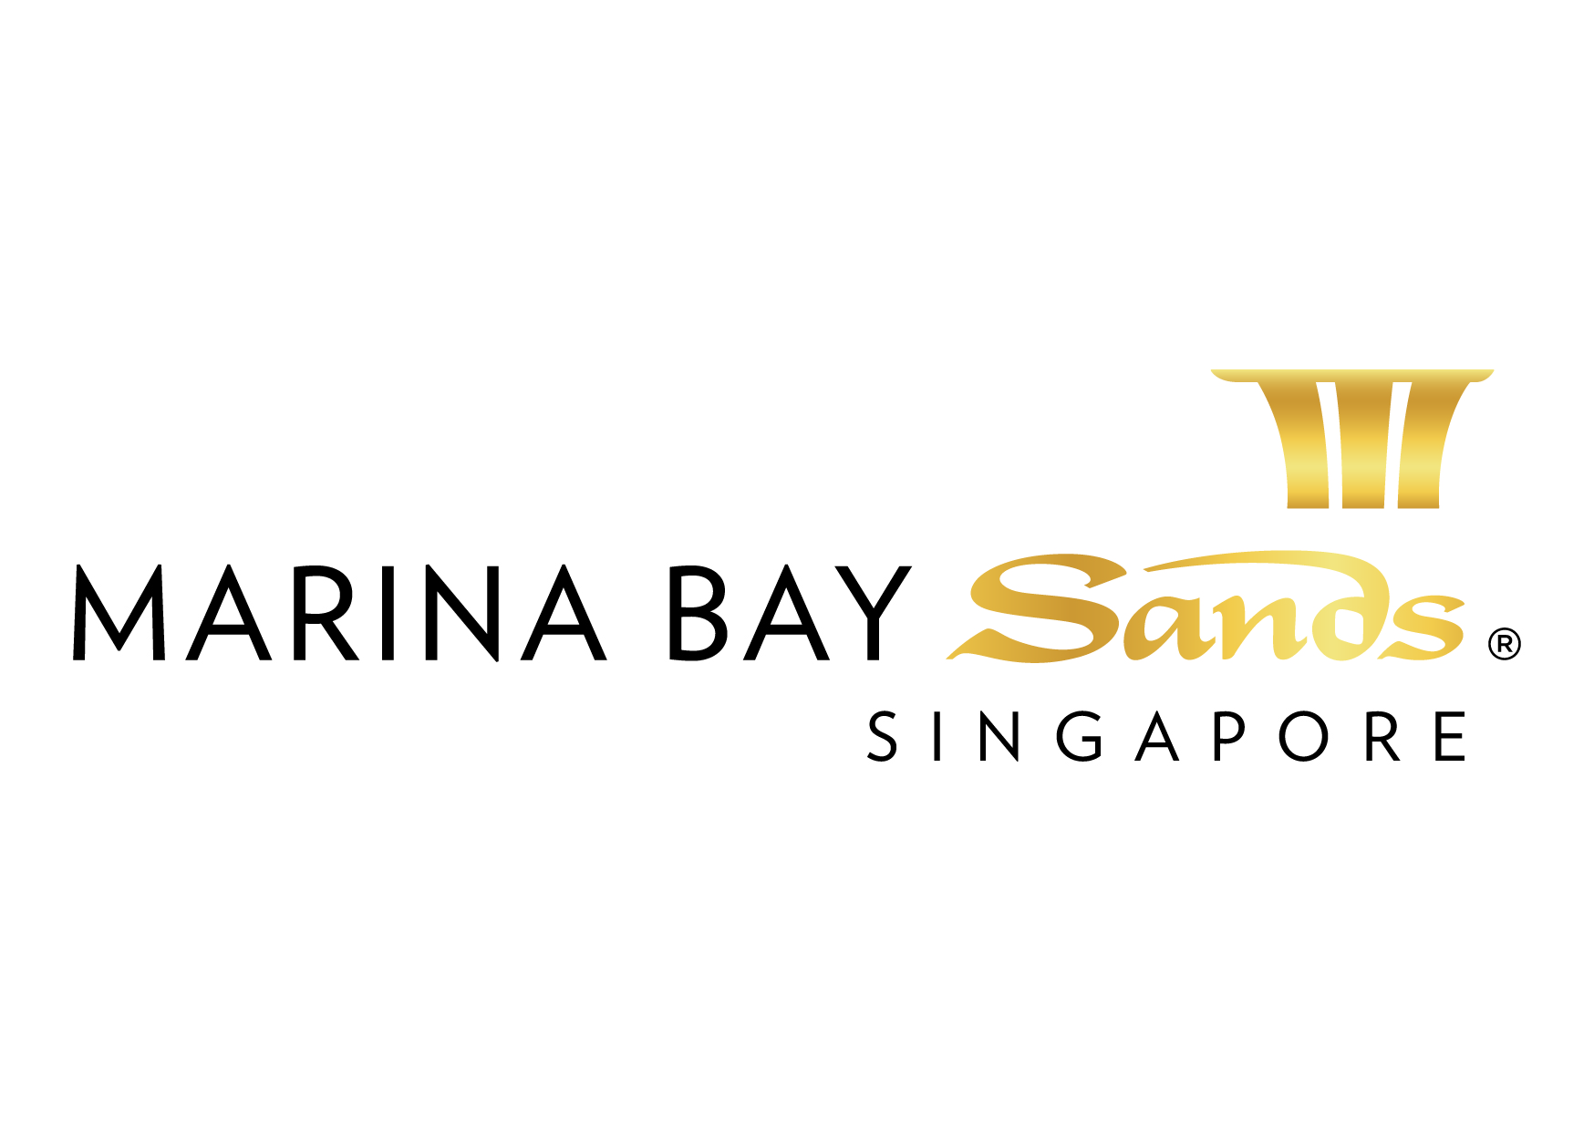

PLUMBING/COMPRESSED AIR/WATER/DRAIN SERVICES

INSTRUCTIONS & CONDITIONS – 2015

INSTRUCTIONS AND CONDITIONS

- SANDS EVENT SERVICES IS THE EXCLUSIVE COMPRESSED AIR/WATER/DRAIN SERVICE PROVIDER. NO OTHER PROVIDER OR COMPRESSED AIR/WATER/DRAIN SERVICE WILL BE ALLOWED ON THE SHOW FLOOR.
- All material and equipment furnished by Sands Event Services for these service orders shall remain Sands Event Services property and shall be removed ONLY by Sands Event Services personnel at the close of the show.
- Wall, column, and permanent building utility outlets are not a part of booth space and are not to be used by exhibitors.
- All equipment must comply with state and local safety codes.
- Prices are based upon current wage rates and are subject to change without notice.
- Exhibitors are encouraged to make their booth connections within their booth. The standard connector for compressed air connector for compressed air outlets is a ¼” AMFLO-C1 connector; the standard connector for water is ½” FIP connector. However, no modification to facility system or equipment is allowed. Exhibitors who are in violation of this will be charged an hourly service charge to repair system or equipment.
- Special equipment requiring company engineering or technicians for assembly, servicing, preparatory work and operation may be executed without Sands Event Services Plumbing personnel. However, if exhibitor requests labour from Sands Event Services, they will be charged an hourly service charge for these services.
- Equipment using water must have inlet and outlet properly marked and identified.
- Unless otherwise directed in writing by exhibitor or his representative, Sands Event Services Plumbing personnel may be required to cut floor coverings to permit installation of service.
- Connection rates listed cover bringing service from main line to booth and do not include connecting equipment. Standard placement for compressed air, water, and drain outlets is at the back wall of line (in-line) and peninsula booths. For island booths, outlets will be placed in the centre of the booth (or at our discretion) unless we receive a floor plan indicating the main location where you require your services.
- Due to the portable nature of the air lines in the Sands Expo & Convention Centre, we recommend that exhibitors supply a filter or other equipment to limit the moisture or water in lines.
- Special supplies such as regulators, strainers, traps, and other such specialized equipment as may be necessary for your booth should be ordered with at least 30 days advanced written notice. Every effort will be made to provide you with all special requirements.
- All utility outlets include up to 16 meter of accomplished distance. Use of additional footage or equipment will be charged at the prevailing labour and material rates.
- Any of your plumbing services that require electricity or electrical labour to connect and/or operate should be ordered on the “Electrical Services Order Form”. You will also be charged for electrical outlets for any services which require power for special plumbing needs, such as pumps, ejectors, and/or compressor outlets.
- Sands Event Services is the exclusive provider at the SECC for this service. When AFSS is required in your booth, please order by calling +65 6688-3888. The mailing address is: Marina Bay Sands, Attn: Sands Expo & Convention Centre - MICE Services Centre, 10 Bayfront Avenue, Singapore 018956.
- Plan view drawing of the display indicating (by shading) the areas/elements that are covered including stairwells and their dimensions. Walks, kiosks, showcases or products with less than 20” of clearance from bottom of the deck or ceiling must be indicated with dimensions.
- Please send perspective/isometric drawings to better define your display.
- All on-site plumbing orders are subject to availability of labour and services.
- All on-site plumbing orders may be delayed due to the nature and requirements of services ordered.

Prices, Policies, and Procedures Subject to Change without prior notice.

GST Registration No. M90364464C

LAST DAY TO RECEIVE ADVANCE RATE IS 17 AUGUST 2015
FORM 15

PLUMBING/COMPRESSED AIR/WATER/DRAIN SERVICES
ORDER FORM – 2015
E-mail or fax forms to:
MARINA BAY SANDS – ATTN: SANDS EXPO & CONVENTION CENTRE – MICE SERVICE CENTRE
10 BAYFRONT AVENUE SINGAPORE 018956
P: +65 6688-3888 F: +65 6688-3889 E: secc@marinabaysands.com
Please indicate total number of pages faxed to ensure complete order was received.
EVENT NAME: HIMSS Asia Pac 15 Digital Healthcare Week |  |  | EVENT DATES: 07-10 September 2015 |  |  | BOOTH # / MTG. ROOM #
EXHIBITING CO. NAME: |  |  | HALL LOCATION: Level 5, Ballroom A-H
STREET ADDRESS: |  | CITY: |  |  | STATE: | ZIP:
TELEPHONE: |  | FAX: |  |  | E-MAIL:
ORDERED BY:  (Print Name) |  |  |  | SIGNATURE:
IMPORTANT: SANDS EVENT SERVICES IS THE EXCLUSIVE COMPRESSED AIR/WATER/DRAIN SERVICE PROVIDER. NO OTHER PROVIDER OR COMPRESSED AIR/WATER/DRAIN SERVICE WILL BE ALLOWED ON THE SHOW FLOOR. TO RECEIVE ADVANCE DISCOUNT PRICES (UNLESS OTHERWISE STATED), SANDS EVENT SERVICES MUST RECEIVE YOUR ORDER WITH FULL PAYMENT BY 5 PM UCT 21 CALENDAR DAYS PRIOR TO SHOW OPENING DATE TO ENSURE AVAILABILITY. ALL OTHER ORDERS WILL BE PROCESSED AT THE STANDARD OR ON-SITE RATE. NO CREDITS WILL BE ISSUED ON SERVICES INSTALLED AS ORDERED EVEN THOUGH NOT USED. ALL ORDERS ARE SUBJECT TO A 7% GST & CANCELLATION FEE. REVIEW INVOICE PRIOR TO DEPARTURE. FOR CREDIT CONSIDERATION, ALL SERVICE CONCERNS MUST BE MADE KNOWN DURING THE SHOW.

ITEM | QTY | ADVANCED RATE | STANDARD RATE | ON-SITE RATE |  | SUBTOTAL  (QTY X PRICE)
COMPRESSED AIR SUPPLY TERMINATED AT GATE VALVE FITTED WITH 9mm QUICK CONNECT COUPLING  Max flow rate 60 lit/min @ 5-7 bar (2.1 cfm @ 80-100 psi) [approx. 1HP] |  | $315.00 | $370.00 | $435.00 |  | $
Max flow rate 120 lit/min @ 5-7 bar (4.2 cfm @ 80-100 psi) [approx. 2HP] |  | $442.00 | $520.00 | $612.00 |  | $
Max flow rate 180 lit/min @ 5-7 bar 6.3 cfm @ 80-100 psi) [approx. 3HP] |  | $621.00 | $730.00 | $859.00 |  | $
COMPRESSED AIR SUPPLY TERMINATED AT GATE VALVE FITTED WITH 12mm QUICK CONNECT COUPLING  Max flow rate 300 lit/min @ 5-7 bar (10.6 cfm @ 80-100 psi) [approx. 5HP] |  | $893.00 | $1,050.00 | $1,235.00 |  | $
Regulator |  | $200.00 | $235.00 | $276.00 |  | $
AIR SERVICE: Pressure and flow rate may vary. No guarantee can be made of minimum or maximum pressures. If pressure is critical, exhibitor should arrange to have a pressure regulator valve installed.
ITEM | QTY | ADVANCED RATE | STANDARD RATE | ON-SITE RATE | SUBTOTAL  (QTY X PRICE)
Water Supply (on consumption) – For Storage Tank ONLY |  | $20/cubic meter  (or part thereof cubic meter) |  |  | $
WATER SUPPLY POINT TERMINATED AT 12mm DIAMETER GATE VALVE WITH 3m RUN OF NYLON HOSE  Flow Rate: 10-12 litres per minute at 1-1.2 bar, waste water to be collected by user’s own waste water container or equipment (water discharge point excluded). |  | $128 | $150 | $176 | $
WASTE WATER COLLECTION TANK WITH PUMP SET AND DISCHARGE HOSE CONNECTED TO NEAREST DRAINAGE POINT Size: 1200mm (L) x 900mm (H) x 760mm (D).  Discharge flow rate at 20 litres per minute, power supply included. |  | $476 | $560 | $659 | $
STAINLESS WASH SINK UNIT COMPLETED WITH WATER SUPPLY AND WASTE DISCHARGE PUMP SET  Discharge flow rate at 20 litres per minute, power supply included. |  | $675 | $794 | $934 | $
DRAINS: Please call to verify drain availability or supplemental charges which may be incurred. This condition pertains to all Exhibit Halls at the SECC. |  |  | TOTAL |  | $
 |  |  | GST 7% |  | $
 |  |  | GRAND TOTAL |  | $
LABOUR RATES (applicable to exhibition halls only)
*Straight Time - $50 per hour minimum of 4 hours from 8 AM – 10 PM, Monday through Sunday including holidays
*Overtime – $75 per hour after 8 hours of work
*Midnight Rate - $150 per hour for any work from 10:01 PM – 07:59 AM.
NOTE: A Service Location Plan (Form 3) must be submitted to process electrical orders. Date & time of the equipment and/or service requested should also be included.

ALL SERVICES PROVIDED BY SANDS EVENT SERVICES

All orders are subject to a cancellation fee if CANCELLED within 21 calendar days prior to show opening date. All services delivered on site cannot be cancelled nor be refunded. All prices are subject to change without prior notice.

PAYMENT MODE Credit card information will be used to guarantee the service request on this order form. (Will be used for any and all Sands Event Services you order in addition to those listed on this form.)

Cheque/ Telegraphic No. _________________________ MAKE PAYABLE TO: MARINA BAY SANDS PTE LTD. MUST BE RECEIVED 14 DAYS PRIOR TO EVENT START DATE.
Credit Card Payment:
Please fill up the Credit Authorisation Form and submit together with front and back of the credit card.
Note: To omit the 3 digit CVV/CVC numbers at the back of the credit card due to security issues.

Cash (only applicable for onsite orders)

Telegraphic Transfer:
Please make payment to:
Bank Name: DBS Bank Ltd
A/C No.: 003-909346-2
A/C Name: Marina Bay Sands Pte Ltd
Swift Code: DBSSSGSG
Reference: Please include the event/event date during Telegraphic Transfer. Failure to do so will result with the wire transfer not properly crediting to your event account.
NOTE: Organisation will be responsible for the payment of all charges incurred from the bank.

Cheque Payment:
All cheques should be crossed and made payable to
Marina Bay Sands Pte Ltd

All payments must be sent directly to:
Marina Bay Sands Pte Ltd
Accounts Receivable
Finance Non-Gaming Department
10 Bayfront Avenue
Singapore 018956
Reference: Please include the show name at the back of the
cheque. Failure to do so will result in cheque not properly
crediting to your event account.

Prices, Policies, and Procedures Subject to Change without prior notice. GST Registration No. M90364464C

