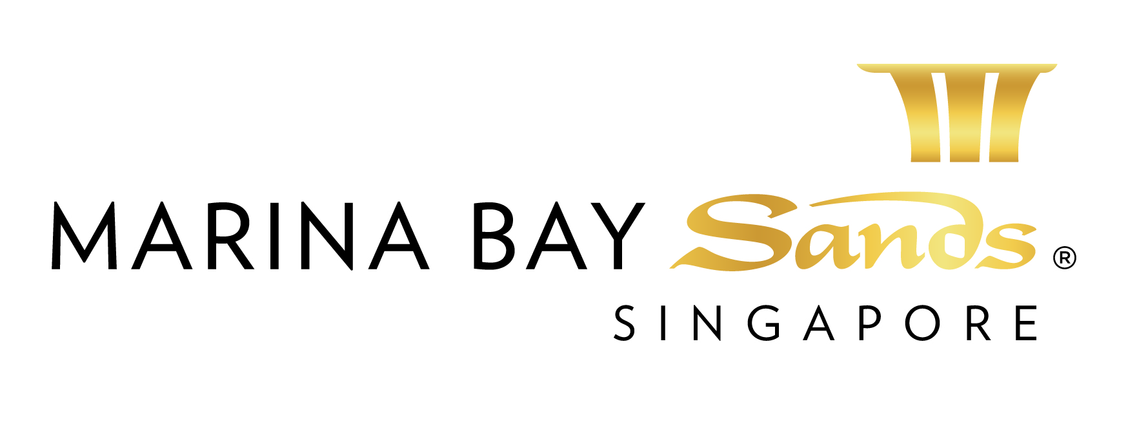

LOGISTICS SERVICES – 2015: HIGH-REACH EQUIPMENTS RENTAL SERVICES

GENERAL NOTES AND CONDITIONS:

- In general, orders for the following services and equipment hire for exhibitions must be submitted to the Centre before the deadline, otherwise a surcharge of 15% will be imposed on the basic rates.
In addition, on-site orders are subject to a surcharge of 30% of the basic rates. However, the Centre reserves the right not to accept any orders received and in such cases, the users will be notified.
Deadline for ordering equipments rental services and equipment for exhibitions are as follows: 14 days before 1st day of tenancy
- All equipment provided by the Centre should only be utilized within licensed venues, exclusively for the specified event.
- Provision of any services / equipment by the Centre is subject to current stock availability at the time of ordering. Orders will be accepted on a “first come, first served” basis.
However, the Centre reserves the right not to accept any order received and in such cases, the users will be notified accordingly.
- If by reason of force majeure, labour difficulties, inventory or any other cause outside the control of the Centre, the Centre is unable to provide all or any of the services or equipment ordered during the whole or any part of the duration of the event, the hirer’s right shall be limited to refund on a pro-rata basis of the charges paid for the services or equipment.
- All equipment operators must possess valid operating license, issued by a recognized local institute / governing body / authority. The Centre’s staff reserve the rights to conduct random checks on operators
- The hirer will be responsible for returning all equipment and related materials to the Centre within one hour on the last open day following the close of the event.
- The hirer will use the equipment in a careful and proper manner. The hirer shall not make any alterations, modifications, attachments and / or additions to the equipment.
- The hirer will be liable for any loss or damage to the equipment arising from the hirer’s negligence, unintentional act or other cause within the reasonable control of the hirer, its representatives, employees, agents, or invitees. In the event of any loss or damage to the equipment for which hirer is liable, the hirer will reimburse the Centre for the total cost of making good or replacement.
- The hirer will be in default if the hirer fails to pay any charges when due or any other indebtedness or fails to return the equipment to the Centre after use.
- Insurance Liability – The Centre will not be responsible for any damages to freight / equipments, pilferages or theft of items whilst in storage or handled by the Centre
- At any time after a default by the hirer, the Centre may terminate the rental services, by notice to the hirer and repossess the equipment. The hirer will remain liable for all unpaid charges and the Centre may apply, and retain all or a portion of the hirer’s security / damage deposit as may be necessary to compensate the Centre for any unpaid charges or damages and expenses incurred on account of default; the Centre may exercise any other rights occurring to a hirer under any applicable law upon a default by the hirer.
- Credit card information stipulated above will be used to guarantee the service request on this order form. If for any reason, this service is not settled at the end of the event, the credit card member whose credit card is noted on this form authorizes the Centre to charge the entire amount without any prior notification.
- All orders must be submitted with full payment, together with the required deposit in SGD.
Please make check on bank draft (to be drawn from local banks) payable to Marina Bay Sands Pte Ltd

Prices, Policies, and Procedures Subject to Change without prior notice.

GST Registration No. M90364464C

LOGISTICS SERVICES ORDER FORM – 2015:
FORM 14B
EXCLUSIVE HIGH-REACH EQUIPMENTS RENTAL SERVICES
E-mail or fax forms to:
MARINA BAY SANDS – ATTN: SANDS EXPO & CONVENTION CENTRE – MICE SERVICE CENTRE
10 BAYFRONT AVENUE SINGAPORE 018956
P: +65 6688-3888 F: +65 6688-3889 E: secc@marinabaysands.com
Please indicate total number of pages faxed to ensure complete order was received.
EVENT NAME: HIMSS Asia Pac 15 Digital Healthcare Week |  |  | EVENT DATES: 07-10 September 2015 |  |  | BOOTH # / MTG. ROOM #
EXHIBITING CO. NAME: |  |  | HALL LOCATION: Level 5, Ballroom A-H
STREET ADDRESS: |  | CITY: |  |  | STATE: | ZIP:
TELEPHONE: |  | FAX: |  |  | E-MAIL:
ORDERED BY:  (Print Name) |  |  |  | SIGNATURE:
IMPORTANT: TO RECEIVE ADVANCE DISCOUNT PRICES (UNLESS OTHERWISE STATED), SANDS EVENT SERVICES MUST RECEIVE YOUR ORDER WITH FULL PAYMENT BY 5 PM PST 21 CALENDAR DAYS PRIOR TO SHOW OPENING DATE TO ENSURE AVAILABILITY. ALL OTHER ORDERS WILL BE PROCESSED AT THE STANDARD OR ON-SITE RATE. NO CREDITS WILL BE ISSUED ON SERVICES INSTALLED AS ORDERED EVEN THOUGH NOT USED. ALL ORDERS ARE SUBJECT TO A 7% GST & CANCELLATION FEE. REVIEW INVOICE PRIOR TO DEPARTURE. FOR CREDIT CONSIDERATION, ALL SERVICE CONCERNS MUST BE MADE KNOWN DURING THE SHOW.

DESCRIPTION | MIN ORDER 4 HRS DURING | QTY | DURATION  ORDERED |  | PER HR (SGD) | SUBTOTAL (SGD) | DEPOSIT
High-Reach Equipments Rental
Electric Scissors-Lifts w/o Operator  Working Height 10.0m |  |  |  |  | $30/hr
Electric Articulated Boom lift w/o Operator  Working Height 11.0m |  |  |  |  | $50/hr
Electric Aerial Work Platform w/o Operator  Working Height 11.0m |  |  |  |  | $25/hr
All equipment operators must possess valid operating license, issued by a recognized local institute / governing body / authority. The Centre’s staff reserve the rights to conduct random checks on operators. |  |  |  | TOTAL
 |  |  | ON-SITE ORDER CHARGE 30%
 |  |  | LATE ORDER CHARGE 15%
 |  |  | GST 7%
 |  |  | GRAND TOTAL

PAYMENT MODE Credit card information will be used to guarantee the service request on this order form. (Will be used for any and all Sands Event Services you order in addition to those listed on this form.)

Cheque/ Telegraphic No. _________________________ MAKE PAYABLE TO: MARINA BAY SANDS PTE LTD. MUST BE RECEIVED 14 DAYS PRIOR TO EVENT START DATE.
Credit Card Payment:
Please fill up the Credit Authorisation Form and submit together with front and back of the credit card.
Note: To omit the 3 digit CVV/CVC numbers at the back of the credit card due to security issues.

Cash (only applicable for onsite orders)

Telegraphic Transfer:
Please make payment to:
Bank Name: DBS Bank Ltd
A/C No.: 003-909346-2
A/C Name: Marina Bay Sands Pte Ltd
Swift Code: DBSSSGSG
Reference: Please include the event/event date during Telegraphic Transfer. Failure to do so will result with the wire transfer not properly crediting to your event account.
NOTE: Organisation will be responsible for the payment of all charges incurred from the bank.

Cheque Payment:
All cheques should be crossed and made payable to
Marina Bay Sands Pte Ltd

All payments must be sent directly to:
Marina Bay Sands Pte Ltd
Accounts Receivable
Finance Non-Gaming Department
10 Bayfront Avenue
Singapore 018956
Reference: Please include the show name at the back of the
cheque. Failure to do so will result in cheque not properly
crediting to your event account.

Prices, Policies, and Procedures Subject to Change without prior notice. GST Registration No. M90364464C

