LAST DAY TO RECEIVE ADVANCE RATE IS 17 AUGUST 2015
FORM 13

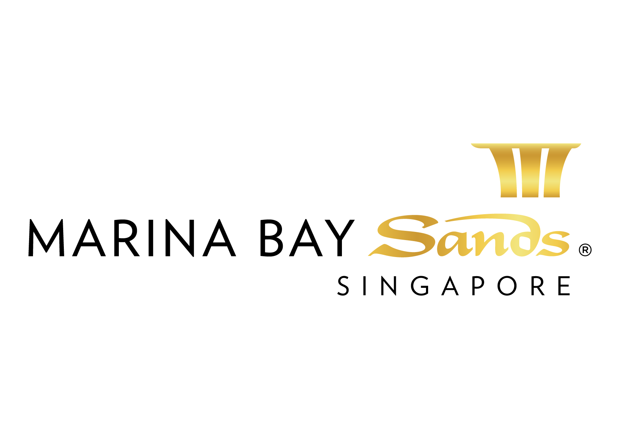 | FIBRE OPTICS / CAT 6 BACKBONE CONNECTIONS  SERVICES ORDER FORM - 2015  E-mail or fax forms to:  MARINA BAY SANDS – ATTN: SANDS EXPO & CONVENTION CENTRE – MICE SERVICE CENTRE  10 BAYFRONT AVENUE SINGAPORE 018956  P: +65 6688-3888 F: +65 6688-3889 E: secc@marinabaysands.com  Please indicate total number of pages faxed to ensure complete order was received.
EVENT NAME: HIMSS Asia Pac 15 Digital Healthcare Week |  |  | EVENT DATES: 07-10 September 2015 |  |  | BOOTH # / MTG. ROOM #
EXHIBITING CO. NAME: |  |  | HALL LOCATION: Level 5, Ballroom A-H
STREET ADDRESS: |  | CITY: |  |  | STATE: | ZIP:
TELEPHONE: |  | FAX: |  |  | E-MAIL:
ORDERED BY:  (Print Name) |  |  |  | SIGNATURE:
IMPORTANT: TO RECEIVE ADVANCE DISCOUNT PRICES (UNLESS OTHERWISE STATED), SANDS EVENT SERVICES MUST RECEIVE YOUR ORDER WITH FULL PAYMENT BY 5 PM UCT 21 CALENDAR DAYS PRIOR TO SHOW OPENING DATE TO ENSURE AVAILABILITY. ALL OTHER ORDERS WILL BE PROCESSED AT THE STANDARD OR ON-SITE RATE. NO CREDITS WILL BE ISSUED ON SERVICES INSTALLED AS ORDERED EVEN THOUGH NOT USED. ALL ORDERS ARE SUBJECT TO A 7% GST & CANCELLATION FEE. REVIEW INVOICE PRIOR TO DEPARTURE. FOR CREDIT CONSIDERATION, ALL SERVICE CONCERNS MUST BE MADE KNOWN DURING THE SHOW.

DESCRIPTION OF SERVICE | QTY | ADVANCED RATE | STANDARD RATE | ON-SITE RATE | SUBTOTAL
- Fiber Optic Backbone – one pair of single mode fiber with LC connectors from MDF Room at telco entry to MICE expo hall or meeting room |  | $1,530 | $1,800 | $2,118
- Fiber Optics backbone – one pair of single mode fiber with LC connection between 2 locations |  | $1,020 | $1,200 | $1,412
- Fiber Optics Backbone – one pair of single mode with LC connectors for connections within 1 meeting room with fibre length less than 50m |  | $510 | $600 | $706
LABOUR CALL
- Labour (applicable to exhibition halls only)  *Straight Time is between 8 AM - 10:00 PM (MON-SUN) including holidays, min 1 hour  *Overtime is after 8 hours of work  *Midnight is any work between 10:01 PM – 07:59 AM (MON-SUN) including holidays  Date/Time:  - Set up computer equipment Set up network  Configuration assistance |  | STRAIGHT TIME $50.00/hour | OVERTIME $75.00/hour | MIDNIGHT RATE $150.00/hour
Hub rental deposits returned upon receiving working hub. Unused portion of deposit(s) returned w/final billing. |  |  | TOTAL
Hub rental(s) must be returned to the Sands Expo & Convention Centre – MICE Service Centre |  |  | GST 7%
TOTAL PAYMENTS MUST ACCOMPANY ORDER. Credit Card users may fax order to +65 6688-3889. |  |  | GRAND TOTAL
*** Advanced Rate applies to orders received WITH PAYMENT 21 days prior to the first day of show.***

NOTE: A Service Location Plan (Form 3) must be submitted to process electrical orders. Date & time of the equipment and/or service requested should also be included.

Notes: 1. the choice of Internet Service Provider (ISP) is at the sole discretion of Sands Event Services.
2. Sands Event Services is the sole provider of all Internet services. The resale of Internet service is strictly prohibited.
3. Sands Event Services reserves the right to append labour to any order if applicable. This includes, though not limited to, troubleshooting and additional assistance.
4. Sands Event Services reserves the right to remove any equipment deemed to be harmful to the network.
5. Sands Event Services does not guarantee the full functionality of specific applications including, though not limited to, VPN; Video Streaming; Net Meeting; Remote
Terminal Services; Citrix; and PC anywhere.
6. Sands Event Services guarantees that Internet services will be delivered no later than one hour before event.
7. Please attach all required floor plans/diagrams.
By signing this order form, you agree to the terms and conditions of the Sands Event Services Internet Department.

ALL SERVICES PROVIDED BY SANDS EVENT SERVICES

All orders are subject to a cancellation fee if CANCELLED within 21 calendar days prior to show opening date. All services delivered on site cannot be cancelled nor be refunded. All prices are subject to change without prior notice.

PAYMENT MODE Credit card information will be used to guarantee the service request on this order form. (Will be used for any and all Sands Event Services you order in addition to those listed on this form.)

Cheque/ Telegraphic No. _________________________ MAKE PAYABLE TO: MARINA BAY SANDS PTE LTD. MUST BE RECEIVED 14 DAYS PRIOR TO EVENT START DATE.
Credit Card Payment:
Please fill up the Credit Authorisation Form and submit together with front and back of the credit card.
Note: To omit the 3 digit CVV/CVC numbers at the back of the credit card due to security issues.

Cash (only applicable for onsite orders)

Telegraphic Transfer:
Please make payment to:
Bank Name: DBS Bank Ltd
A/C No.: 003-909346-2
A/C Name: Marina Bay Sands Pte Ltd
Swift Code: DBSSSGSG
Reference: Please include the event/event date during Telegraphic Transfer. Failure to do so will result with the wire transfer not properly crediting to your event account.
NOTE: Organisation will be responsible for the payment of all charges incurred from the bank.

Cheque Payment:
All cheques should be crossed and made payable to
Marina Bay Sands Pte Ltd

All payments must be sent directly to:
Marina Bay Sands Pte Ltd
Accounts Receivable
Finance Non-Gaming Department
10 Bayfront Avenue
Singapore 018956
Reference: Please include the show name at the back of the
cheque. Failure to do so will result in cheque not properly
crediting to your event account.

Prices, Policies, and Procedures Subject to Change without prior notice. GST Registration No. M90364464C

