FORM 1

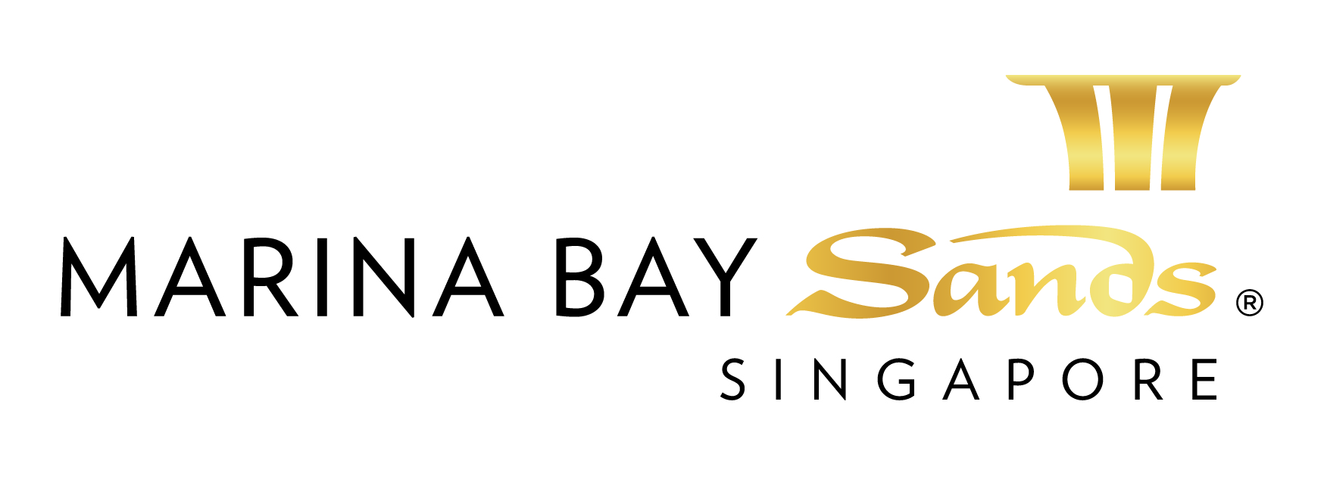 | CREDIT CARD AUTHORISATION/METHOD OF PAYMENT FORM 2015  E-mail or fax forms to:  MARINA BAY SANDS – ATTN: SANDS EXPO & CONVENTION CENTRE – MICE SERVICE CENTRE  10 BAYFRONT AVENUE SINGAPORE 018956  P: +65 6688-3888 F: +65 6688-3889 E: secc@marinabaysands.com  Please indicate total number of pages faxed to ensure complete order was received.
EVENT NAME: HIMSS Asia Pac 15 Digital Healthcare Week |  |  | EVENT DATES: 07-10 September 2015 |  |  | BOOTH # / MTG. ROOM #
EXHIBITING CO. NAME: |  |  | HALL LOCATION: Level 5, Ballroom A-H
STREET ADDRESS: |  | CITY: |  |  | STATE: | ZIP:
TELEPHONE: |  | FAX: |  |  | E-MAIL:
ORDERED BY:  (Print Name) |  |  |  | SIGNATURE:
IMPORTANT: TO RECEIVE ADVANCE DISCOUNT PRICES (UNLESS OTHERWISE STATED) SANDS EVENT SERVICES MUST RECEIVE YOUR ORDER WITH FULL PAYMENT BY 5 PM UTC 21 CALENDAR DAYS PRIOR TO SHOW OPENING DATE TO ENSURE AVAILABILITY. ALL OTHER ORDERS WILL BE PROCESSED AT THE STANDARD OR ON-SITE RATE. NO CREDITS WILL BE ISSUED ON SERVICES INSTALLED AS ORDERED EVEN THOUGH NOT USED. ALL ORDERS ARE SUBJECT TO A 7% GST & CANCELLATION FEE. REVIEW INVOICE PRIOR TO DEPARTURE. FOR CREDIT CONSIDERATION, ALL SERVICE CONCERNS MUST BE MADE KNOWN DURING THE SHOW.

METHOD OF PAYMENT & AUTHORISATION (will be used for all Sands Event Services you order or incur):

Credit Card (please complete information below)
All credit Card Authorization Form submitted must be accompanied with the scanned credit card (front and back).
Note: To omit the 3 digit CVV/CVC numbers at the back of the credit card due to security issues.

Personal Credit Card: American Express Diners Club JCB MasterCard VISA

Company Credit Card: American Express Diners Club JCB MasterCard VISA

Credit Card Number:

Expiration Date: Cardholder’s Name:

Cardholder’s Signature:

Cardholder’s Billing Address:

City/State/Zip:

IF YOU WILL NOT BE ATTENDING THE EVENT, PLEASE INDICATE PERSON(S) AUTHORISED TO SIGN ON YOUR BEHALF.

OTHER AUTHORISED SIGNER(S):

Print Name Signature

Print Name Signature

We recommend that this form be sent to us via Fax or secured/encrypted email. While we have implemented procedures to safeguard and secure your information, we are unable to verify the security of electronic transmissions of such information to us and shall not be liable or responsible for any unauthorised access or loss of information submitted to us.

SERVICES TO BE COVERED BY THIS CARD: ALL
AUDIO/VISUAL HIGH REACH EQUIPMENT PLANT AND FLORAL
BOOTH CLEANING SERVICES INTERNET PIPED SERVICES (AIR, WATER, DRAIN)
BUSINESS CENTRE SERVICES LABOR TELECOMMUNICATIONS – ICT
CATERING LOGISTIC SERVICES TELEVISION PROGRAM SERVICES
ELECTRICAL MAIL CENTRE SERVICES TRUSS/LIGHTING RENTAL
HANGING APPLICATIONS/RIGGING MATERIAL HANDLING EQUIPMENT OTHER

OTHER INFORMATION

All invoices need to be settled prior to show close unless special billing privileges have been established with the Sands Expo & Convention Centre. Credits will not be issued on services installed as ordered even though not used. All orders are subject to a CANCELLATION FEE. Please review all work orders and invoices prior to leaving show site. For credit consideration, all service concerns must be made known during the show. Please read all forms thoroughly for all instructions and conditions prior to placing orders.

THIS FORM CAN BE USED FOR SERVICES DELIVERED TO THE SANDS EXPO & CONVENTION CENTRE AND/OR
THE MARINA BAY SANDS HOTEL.

