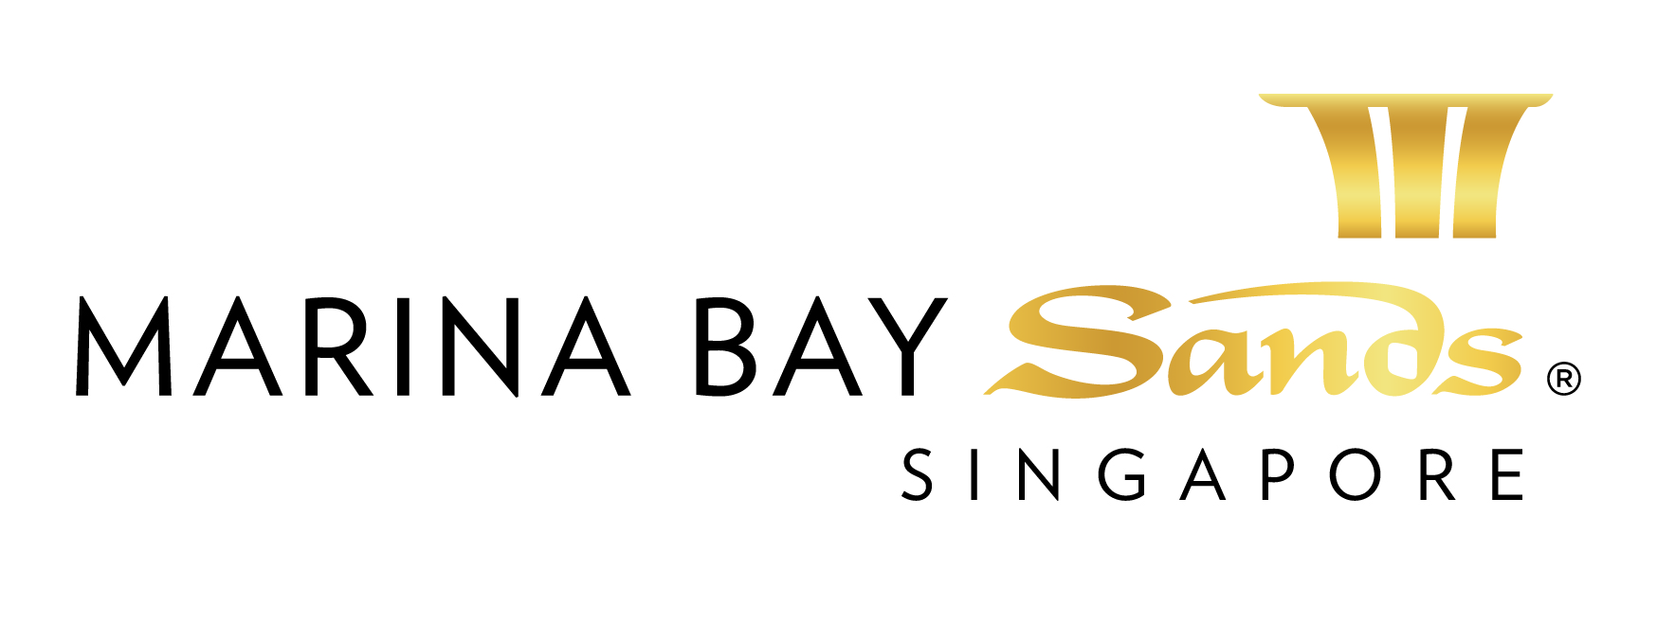

GENERAL NOTES AND CONDITIONS

- In general, orders for the following services and equipment hire for exhibitions must be submitted to the Centre before the deadline, otherwise a surcharge of 15% will be imposed on the basic rates. In addition, on-site orders are subject to a surcharge of 30% of the basic rates. However, the Centre reserves the right not to accept any orders received and in such cases, the users will be notified.
Deadline for ordering services are as follows: 14 days before 1st day of tenancy
- All equipment provided by the Centre should only be utilized within licensed venues, exclusively for the specified event.
- Provision of any services / equipment by the Centre is subject to current stock availability at the time of ordering. Orders will be accepted on a “first come, first served” basis. However, the Centre reserves the right not to accept any order received and in such cases, the users will be notified accordingly.
- If by reason of force majeure, labour difficulties, inventory or any other cause outside the control of the Centre, the Centre is unable to provide all or any of the services or equipment ordered during the whole or any part of the duration of the event, the hirer’s right shall be limited to refund on a pro-rata basis of the charges paid for the services or equipment.
- Hall and booth cleaning services include the followings:
  - Empty and clean wastepaper bins.
  - Wipe clean counter / desk tops etc (not exhibits)
  - Vacuum / sweep and mop stand floors and gangways
- Complete cleaning services will be carried out once daily either before opening or after closing of the exhibition during show open days with stand-by cleaners.
- Booth cleaning does not include removal of oil spillage, paints and other liquid deposited on the floors, walls, and any other surfaces.
- Removal of abandoned stand materials, empty crates, discarded displays / exhibits, hazardous wastes is primarily the responsibility of contractors / exhibitors.
- Hall / booth cleaning and rubbish disposal services are provided to event organizers but not individual contractors / exhibitors. Organizers are responsible for settling the charges.
- In the event where abandoned materials are not cleared by the contractors / exhibitors, the Venue will forward the cleaning and waste management charges to the event organizer.
- Insurance Liability – The Centre will not be responsible for any damages to freight / equipments, pilferages or theft of items whilst in storage or handled by the Centre
- Credit card information stipulated above will be used to guarantee the service request on this order form. If for any reason, this service is not settled at the end of the event, the credit card member whose credit card is noted on this form authorizes the Centre to charge the entire amount without any prior notification.
- All orders must be submitted with full payment, together with the required deposit in SGD.
Please make check on bank draft (to be drawn from local banks) payable to Marina Bay Sands Pte Ltd

Prices, Policies, and Procedures Subject to Change without prior notice.
GST Registration No. M90364464C

LAST DAY TO RECEIVE ADVANCE RATE IS 17 AUGUST 2015
FORM 8

CLEANING SERVICES ORDER FORM - 2015
E-mail or fax forms to:
MARINA BAY SANDS – ATTN: SANDS EXPO & CONVENTION CENTRE – MICE SERVICE CENTRE
10 BAYFRONT AVENUE SINGAPORE 018956
P: +65 6688-3888 F: +65 6688-3889 E: secc@marinabaysands.com
Please indicate total number of pages faxed to ensure complete order was received.
EVENT NAME: HIMSS Asia Pac 15 Digital Healthcare Week |  |  | EVENT DATES: 07-10 September 2015 |  |  | BOOTH # / MTG. ROOM #
EXHIBITING CO. NAME: |  |  | HALL LOCATION: Level 5, Ballroom A-H
STREET ADDRESS: |  | CITY: |  |  | STATE: | ZIP:
TELEPHONE: |  | FAX: |  |  | E-MAIL:
ORDERED BY:  (Print Name) |  |  |  | SIGNATURE:
IMPORTANT: SANDS EVENT SERVICES ARE THE EXCLUSIVE BOOTH CLEANING PROVIDER AT SECC. NO OTHER PROVIDER OR CLEANING SERVICE WILL BE ALLOWED ON THE SHOW FLOOR, EXCEPT FOR INITIAL WIPE DOWN. NO CREDITS WILL BE ISSUED ON SERVICES INSTALLED AS ORDERED EVEN THOUGH NOT USED. TO RECEIVE ADVANCE DISCOUNT PRICES (UNLESS OTHERWISE STATED), SANDS EVENT SERVICES MUST RECEIVE YOUR ORDER WITH FULL PAYMENT BY 5 PM UCT 21 CALENDAR DAYS PRIOR TO SHOW OPENING DATE TO ENSURE AVAILABILITY. ALL ORDERS ARE SUBJECT TO A 7% GST & CANCELLATION FEE. REVIEW INVOICE PRIOR TO DEPARTURE. FOR CREDIT CONSIDERATION, ALL SERVICE CONCERNS MUST BE MADE KNOWN DURING THE SHOW.

DESCRIPTION | QTY / M² | SGD/ M² / DAY | TOTAL (SGD)
Hall / Booth Cleaning Service
General Cleaning of Special Design Booth |  | $2.00 / m² / Day  (Minimum 20 m²)

Ballroom /Meeting Room Cleaning Service
Ballroom / Meeting Room Cleaning Service  (Applicable for exhibitions in Ballroom and Meeting Rooms) |  | $0.25 / m² / Day  (Minimum 1,000 m²)

Description | Per Skip (SGD) | Total (SGD)
Rubbish Disposal Service
Disposal by skip (of approximate 18 cbm) of general exhibition wastes like empty boxes and rubbish generated by organizers, contractors, exhibitors, etc. inclusive of NEA disposal fee. The skip is capped at 3 tons/skip. Excess tonnage will be billed to user @ NEA fee S$77/ton. | $520
Disposal by skip (of approximate 18 cbm) of abandoned exhibition materials like empty crates, booth materials, decoration off-cuts, discarded exhibits/displays, etc. (optional service on request only), inclusive of NEA disposal fee. The skip is capped at 3 tons/skip. Excess tonnage will be billed to user @ NEA fee S$77/ton. | $650
Disposal by skip (of approximate 18 cbm) storage charges (complimentary for first three (3) working days). | $20 / day
 | TOTAL
 | GST 7%
 | GRAND TOTAL

PAYMENT MODE Credit card information will be used to guarantee the service request on this order form. (Will be used for any and all Sands Event Services you order in addition to those listed on this form.)

Cheque/ Telegraphic No. _________________________ MAKE PAYABLE TO: MARINA BAY SANDS PTE LTD. MUST BE RECEIVED 14 DAYS PRIOR TO EVENT START DATE.
Credit Card Payment:
Please fill up the Credit Authorisation Form and submit together with front and back of the credit card.
Note: To omit the 3 digit CVV/CVC numbers at the back of the credit card due to security issues.

Cash (only applicable for onsite orders)

Telegraphic Transfer:
Please make payment to:
Bank Name: DBS Bank Ltd
A/C No.: 003-909346-2
A/C Name: Marina Bay Sands Pte Ltd
Swift Code: DBSSSGSG
Reference: Please include the event/event date during Telegraphic Transfer. Failure to do so will result with the wire transfer not properly crediting to your event account.
NOTE: Organisation will be responsible for the payment of all charges incurred from the bank.

Cheque Payment:
All cheques should be crossed and made payable to
Marina Bay Sands Pte Ltd

All payments must be sent directly to:
Marina Bay Sands Pte Ltd
Accounts Receivable
Finance Non-Gaming Department
10 Bayfront Avenue
Singapore 018956
Reference: Please include the show name at the back of the
cheque. Failure to do so will result in cheque not properly
crediting to your event account.

Prices, Policies, and Procedures Subject to Change without prior notice.

GST Registration No. M90364464C

