October 28, 2015
Christopher Capot
Director, Corporate Relations
Elsevier
+1 917 704 5174
c.capot@elsevier.com

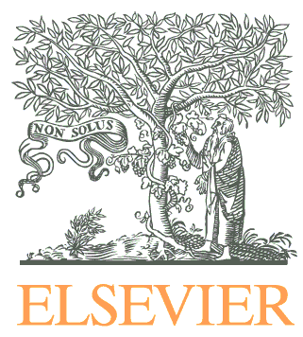

HIMSS-Elsevier Digital Healthcare Award Program Launches for the First Time in the Middle East

Dubai, October 28, 2015 – As part of the HIMSS Middle East UAE ehealth Week in December, Elsevier, a world-leading provider of scientific, technical and medical information products and services, and the Healthcare Information and Management Systems Society (HIMSS) will feature the HIMSS-Elsevier Digital Healthcare Award to recognize outstanding achievements in the implementation and usage of health information and technology from hospitals in the Middle East.

The award promotes Information and Communication Technologies (ICT) adoption through sharing information and best practices in areas such as implementation strategies, financial return on investments and value of the systems to improve patient care and outcomes.

Award nominations for HIMSS Middle East UAE eHealth Week have already begun; applications are open to all public and private healthcare organizations based in the Middle East. Nominees are required to be baseline with HIMSS Analytics EMR Adoption Model (EMRAM) and to achieve a minimum of Stage 2 on the HIMSS Analytics EMRAM scale.

Award recipients will be announced and honored at HIMSS UAE eHealth Week (7-10 December, 2015). More information can be found on the HIMSS Middle East website: www.himssmiddleeast.com.

The Elsevier-HIMSS collaboration on the Healthcare Award is a global initiative, also including programs for Asia Pacific and Europe.

For more information go to: https://www.uaeehealthweek.org

---

About Elsevier
Elsevier is a world-leading provider of information solutions that enhance the performance of science, health, and technology professionals, empowering them to make better decisions, deliver better care, and sometimes make groundbreaking discoveries that advance the boundaries of knowledge and human progress. Elsevier provides web-based, digital solutions — among them ScienceDirect, Scopus, Elsevier Research Intelligence and ClinicalKey — and publishes more than 2,500 journals, including The Lancet and Cell, and more than 33,000 book titles, including a number of iconic reference works. Elsevier is part of RELX Group plc, a world-leading provider of information solutions for professional customers across industries. www.elsevier.com

Media contact
Christopher Capot
Director, Corporate Relations
Elsevier
+1 917 704 5174
c.capot@elsevier.com

